|  |  |  |  |  |  |  |  |  |  |  |  |  |  |  |  |  |  |  |
| --- | --- | --- | --- | --- | --- | --- | --- | --- | --- | --- | --- | --- | --- | --- | --- | --- | --- | --- |
|  |  | eLab Book  HDip Web Development  **WEBDEV2017**  Firstname Surname  Stephen Gregan   |  |  | | --- | --- | | *Date : 23/10/2018* |  | | *Last Lab* |  | |  |  | | *Version:* | *1* | | *Status:* | *Draft / Release* | |  |  | |  |  | |  |  | |

Document Control

|  |  |  |
| --- | --- | --- |
| Contributors | | |
| **Name/Position** | **Organization** | **Contact Details** |
| Stephen Gregan | N/A | grego@live.ie |
|  |  |  |

|  |  |  |  |
| --- | --- | --- | --- |
| Version History | | | |
| **Date** | **Version** | **Status** | **Comments** |
| 23/10/2018 | V1.0 | Completed |  |
|  |  |  |  |
|  |  |  |  |

|  |
| --- |
| Changes since last version |
|  |

|  |
| --- |
| Known Omissions |
|  |

Table of Contents

1 Lab 1.1 : The Description 4

1.1 Problem definition 4

1.2 Design 4

1.3 Website folder structure 4

1.4 Code 4

1.5 Screens 4

1.6 Testing 4

1.7 References 4

2 Lab 1.1 : The Description 5

2.1 Problem definition 5

2.2 Design 5

2.3 Website folder structure 5

2.4 Code 5

2.5 Screens 5

2.6 Testing 5

2.7 References 5

3 Lab write up template 8

3.1 Problem definition 8

3.2 Design 8

3.3 Website folder structure 8

3.4 Code 8

3.5 Screens 8

3.6 Testing 8

3.7 References 8

# Lab 2.1 : The Description

## Problem definition

Using the one page CV website created for Lab 1.2 create an external style sheet and improve the presentation of the site.

## Design

Display a webpage in the Chrome browser with

* Add CSS file(s) to the CSS folder.
* Add link tag to the <head> section.
* Set default font and font size for all text using a selector on <html> and <body>.
* Set a background color on the whole page using a selector on <html> and <body>.
* Put a class=”colourband” on the heading tags and create a selector to put a colored box around them.
* Set a selector for h1, h2, h3 and give them font sizes of 24px, 18px, 14px.
* Set a selector for p and give it a font size of 12px.

## Website folder structure

WEBLAB2-1

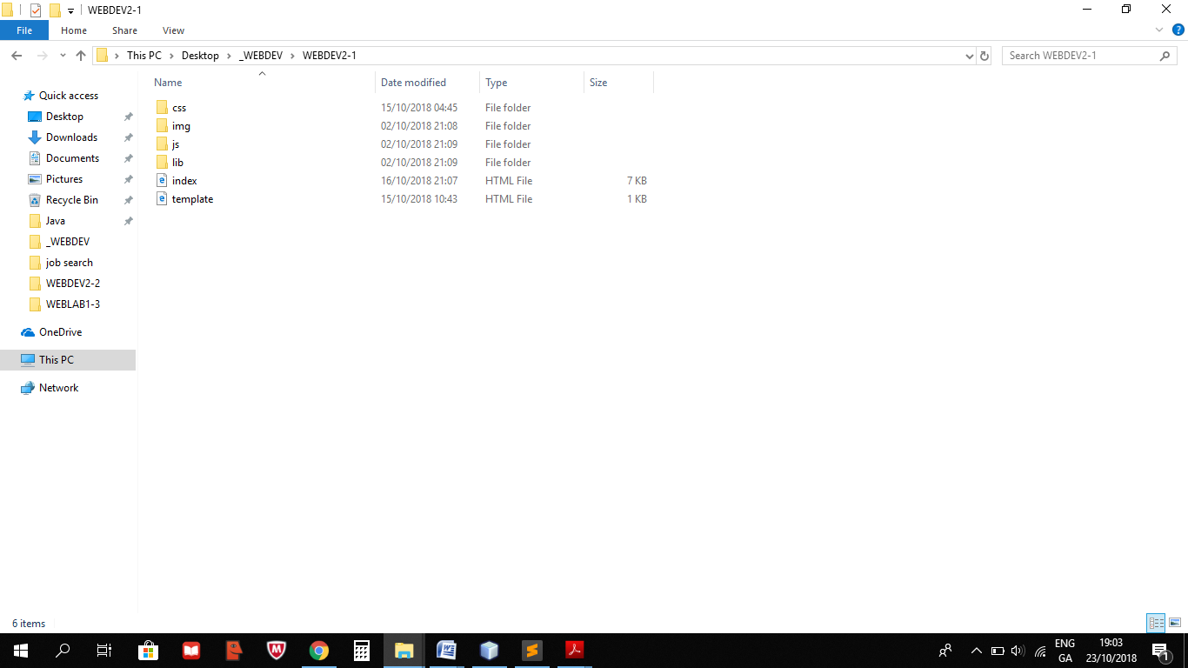

## Code

**Index.html**

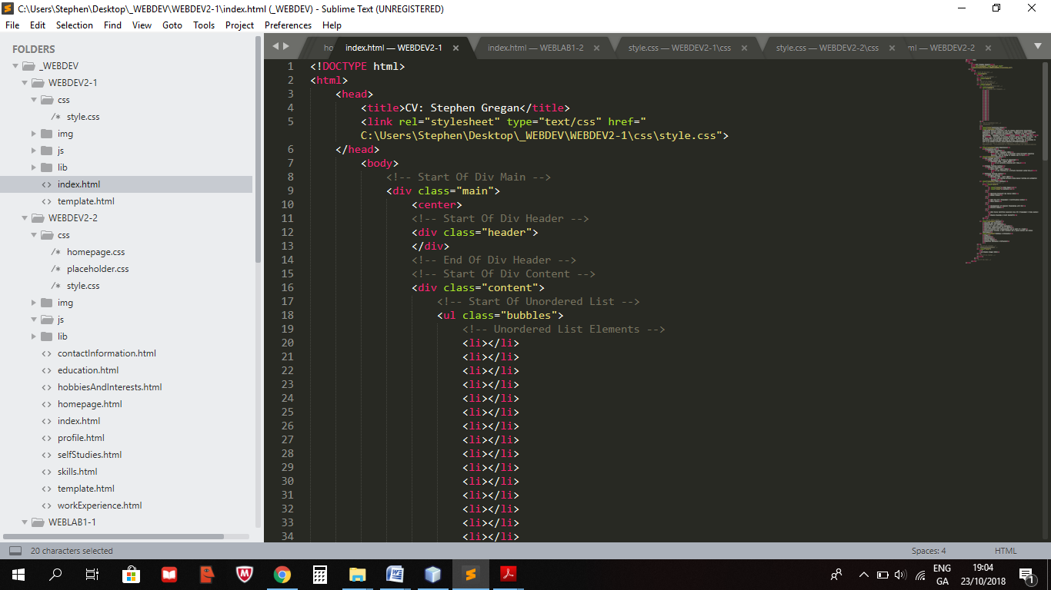

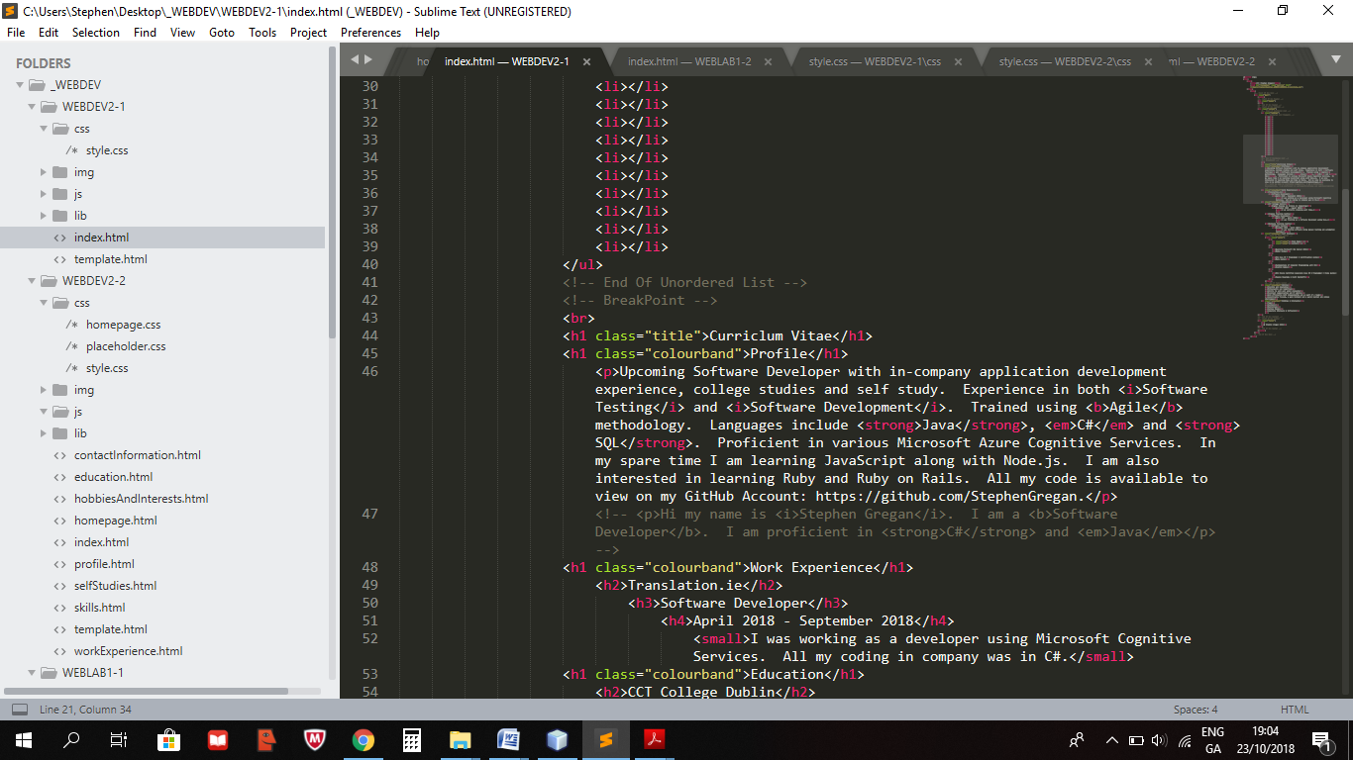

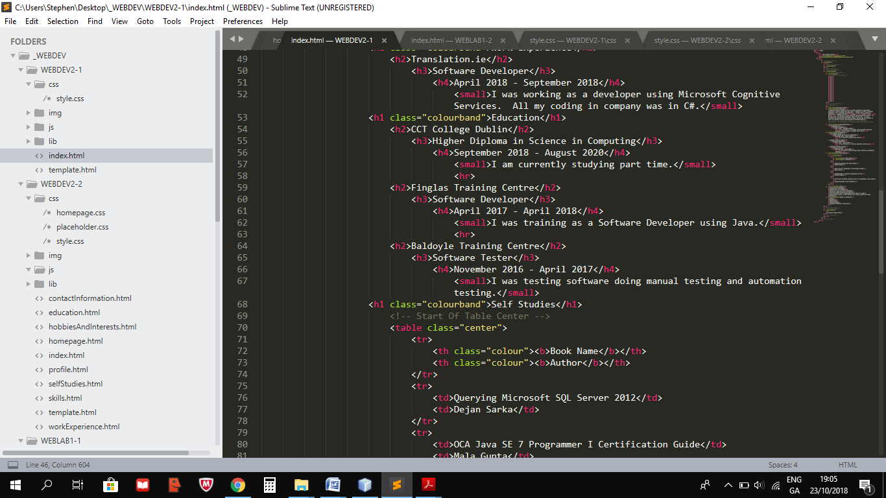

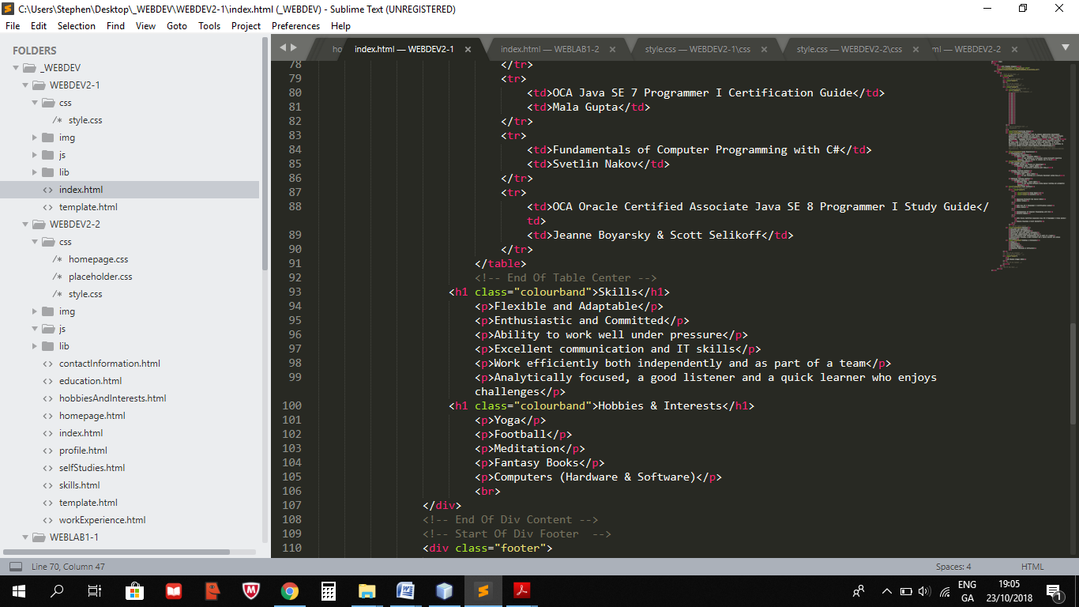

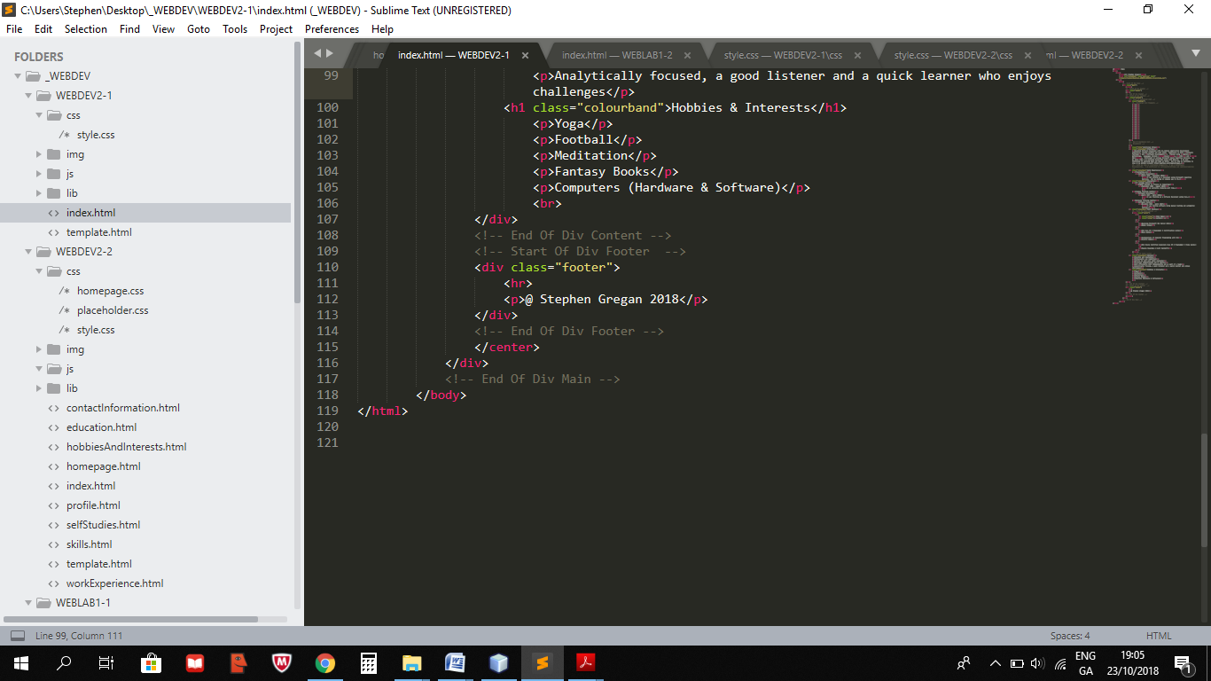

**Style.css**

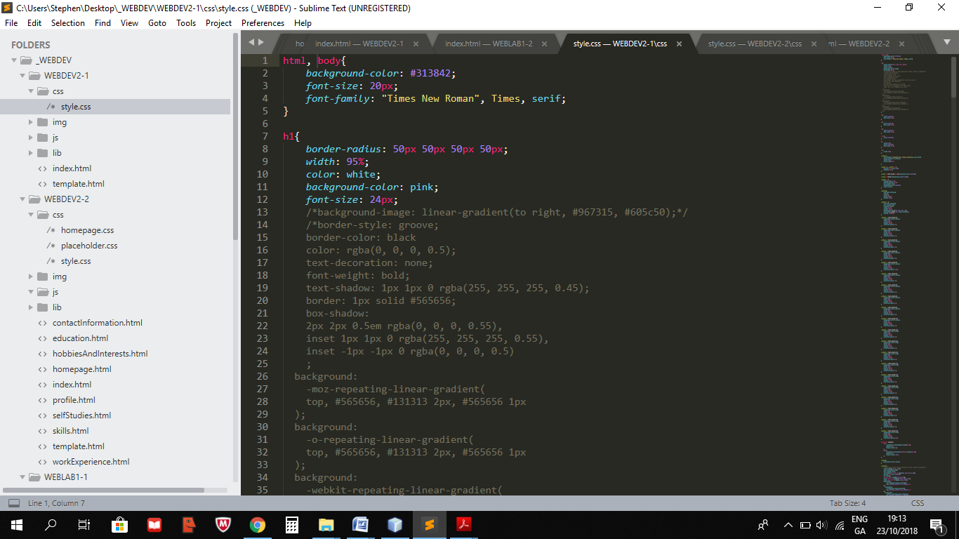

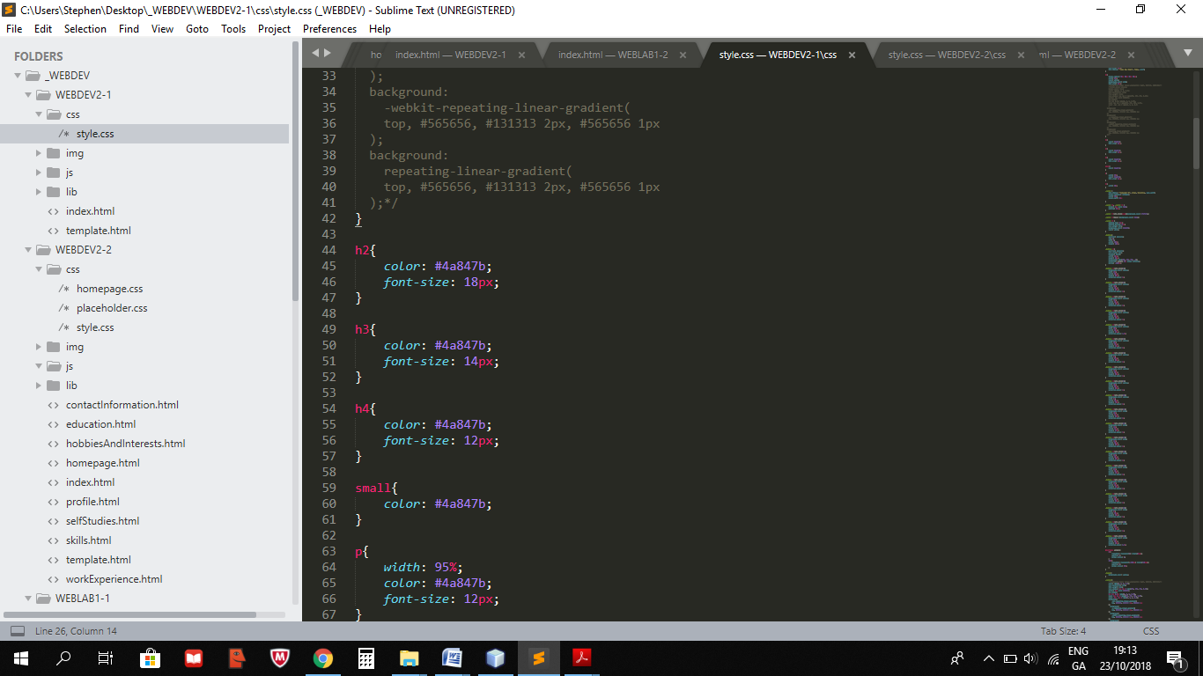

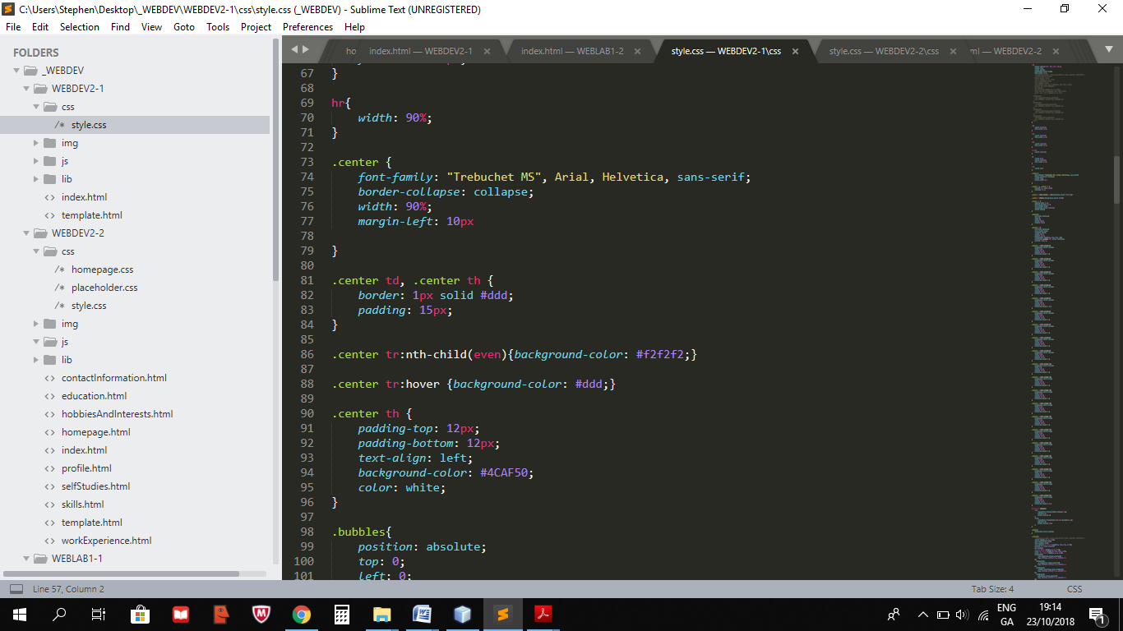

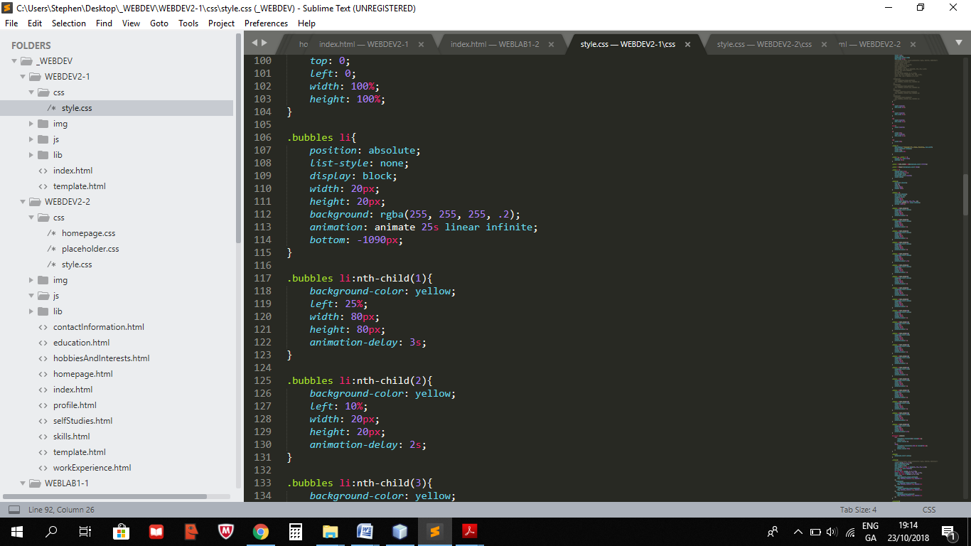

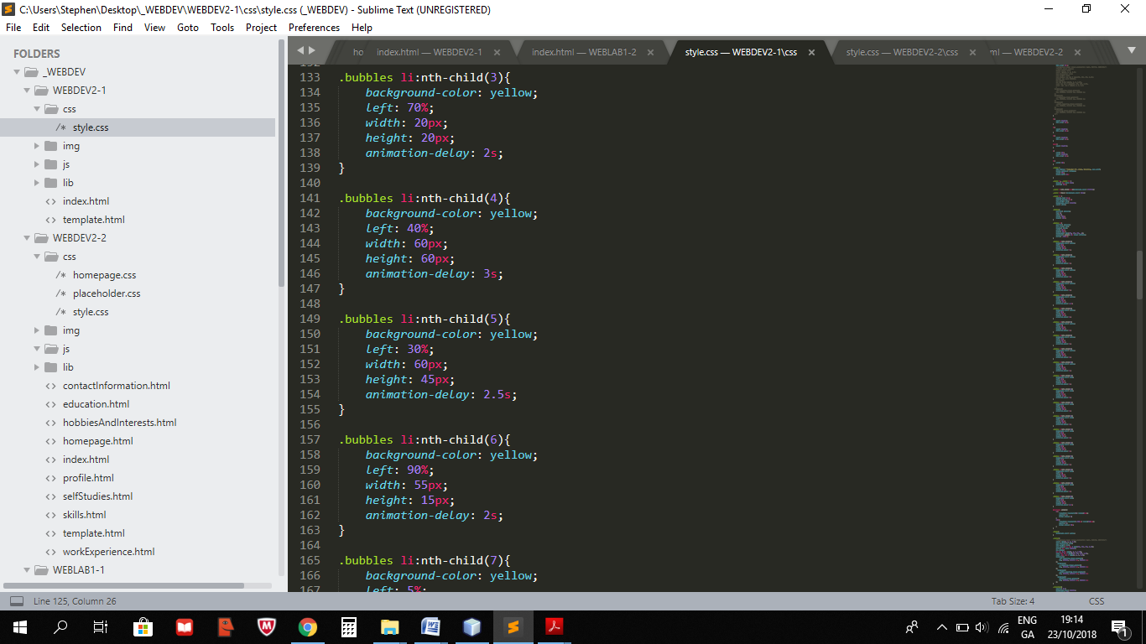

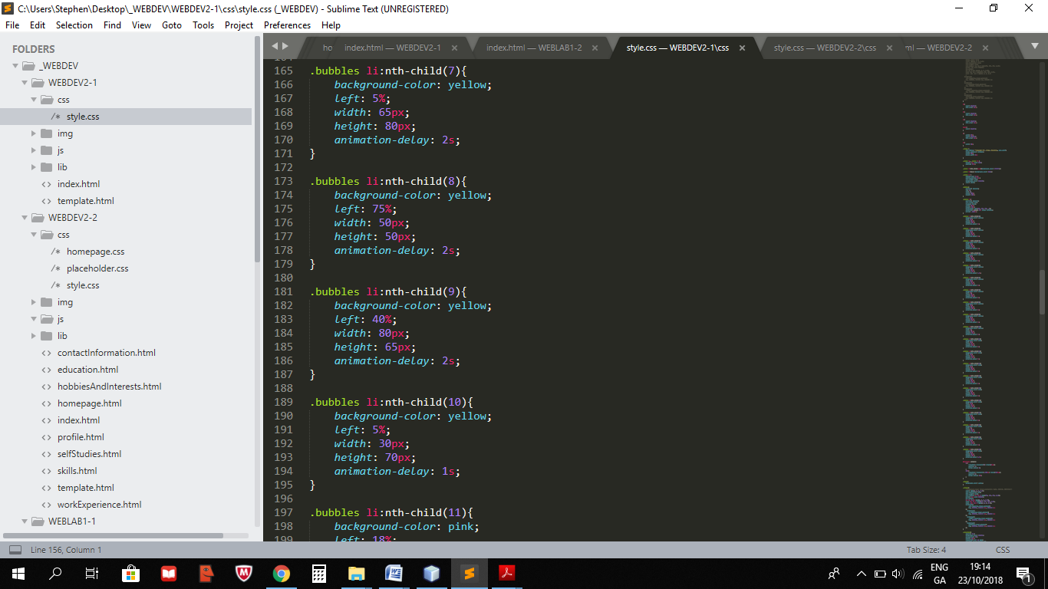

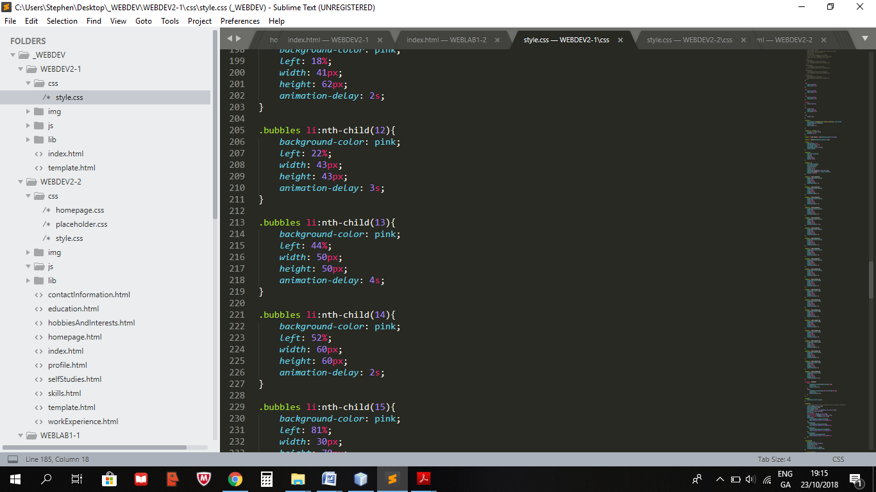

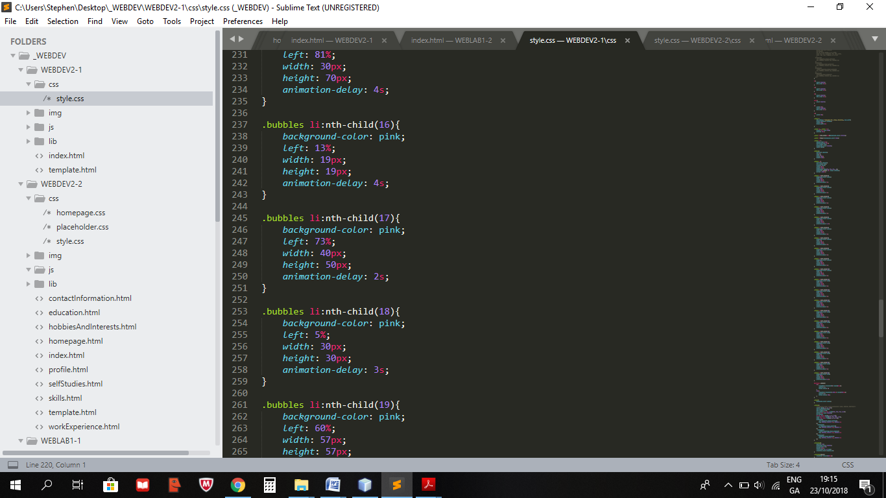

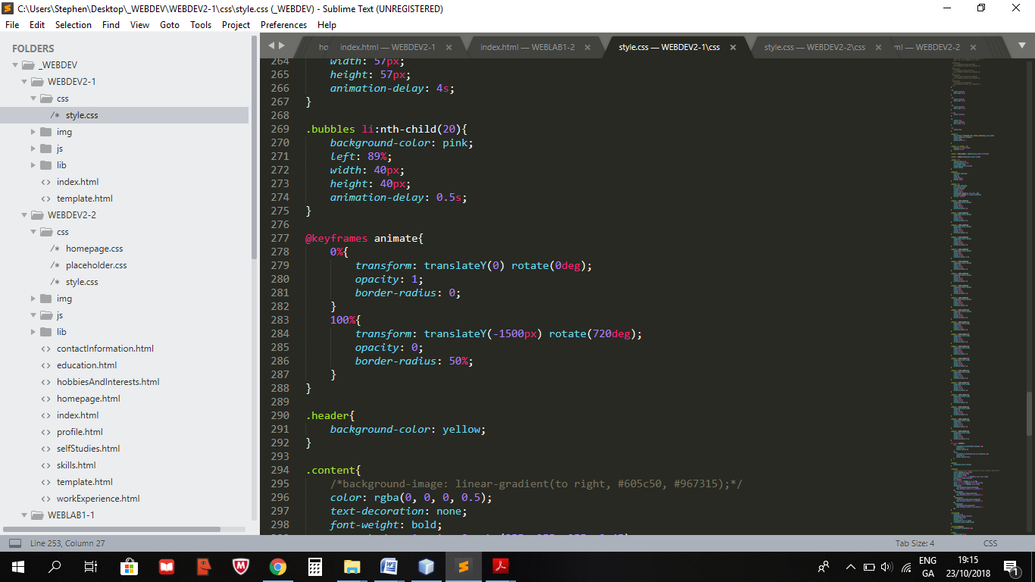

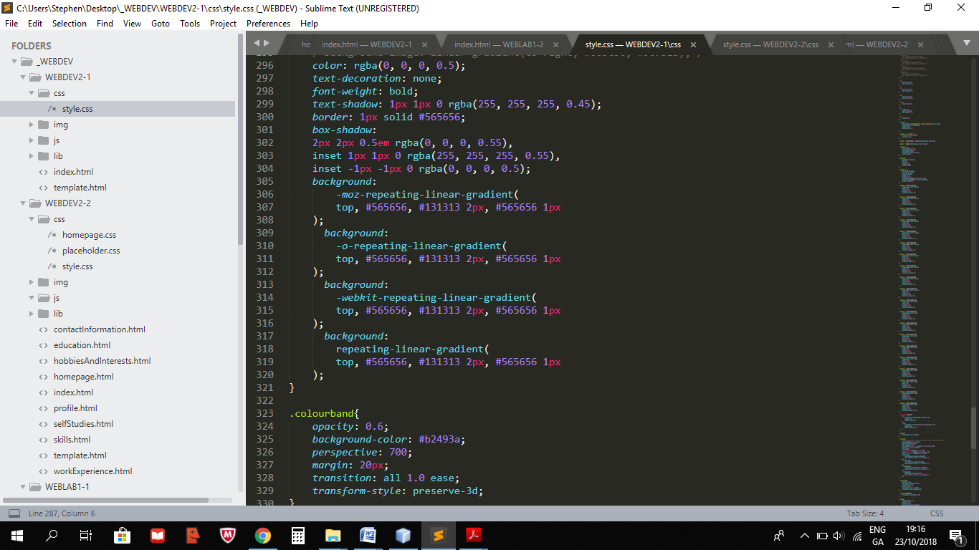

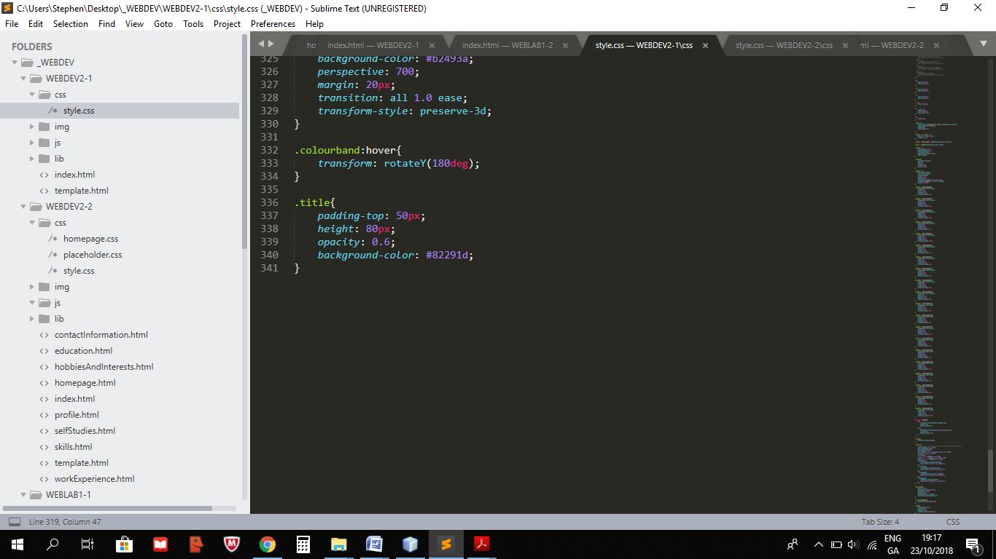

## Screens

**Index.html**

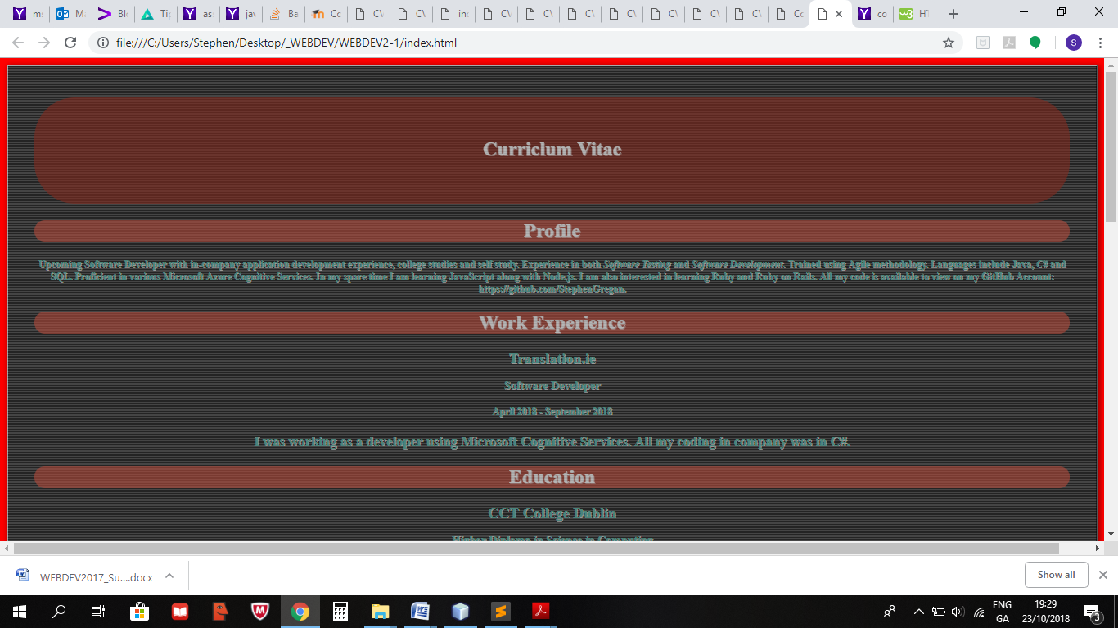

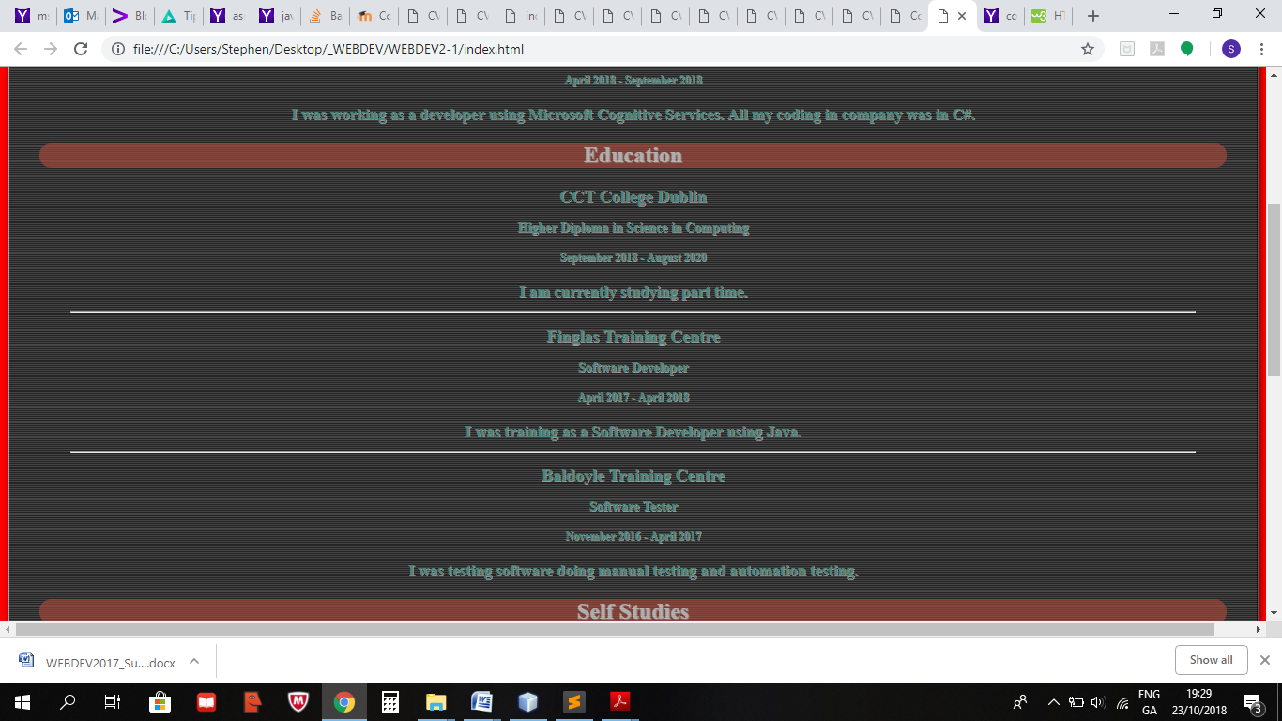

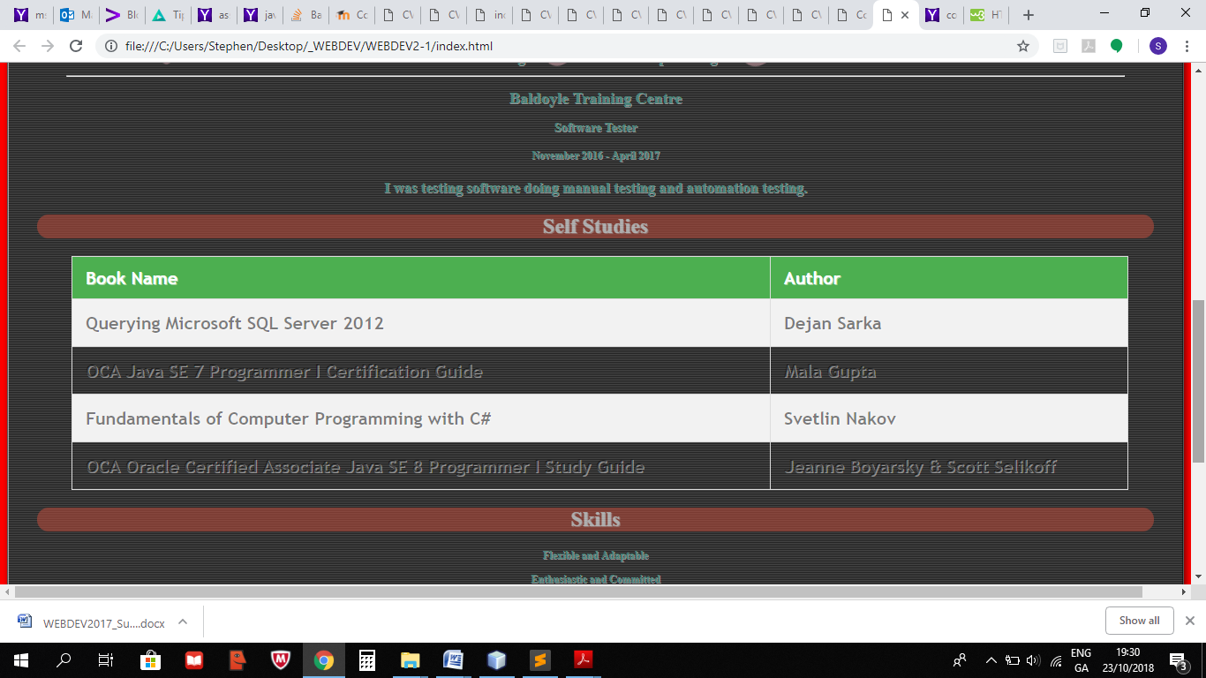

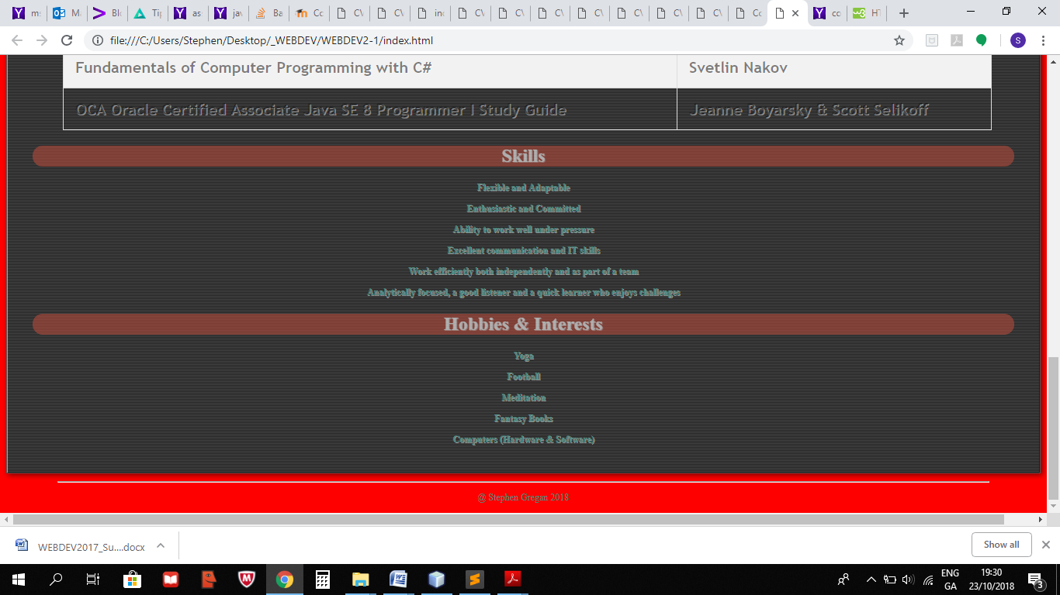

## Testing

Checked in Chrome and Internet Explorer.

## References

https://www.w3schools.com/

# Lab 2.2 : The Description

## Problem definition

Using the multipage site developed in WEBDEV1-3 apply CSS styles to improve the general presentation and

then style the menu and table.

## Design

Display a webpage in the Chrome browser with

* Add CSS file(s) to the CSS folder.
* Add link tag to the <head> section.
* Use CSS selectors to improve the presentation of the site.
* Check the presentation on headers and paragraphs has improved as expected.
* Add link tag to every HTML page.
* The menu/table on the multipage site.
* Add the class=”active”.

## Website folder structure

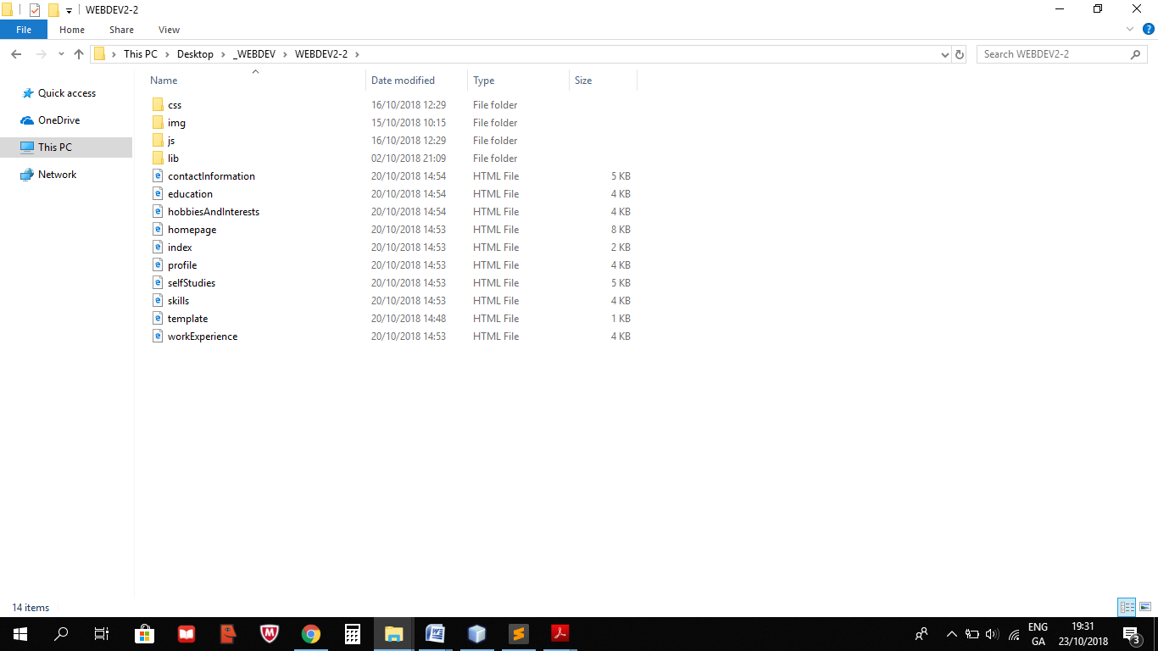

## Code

**Index.html**

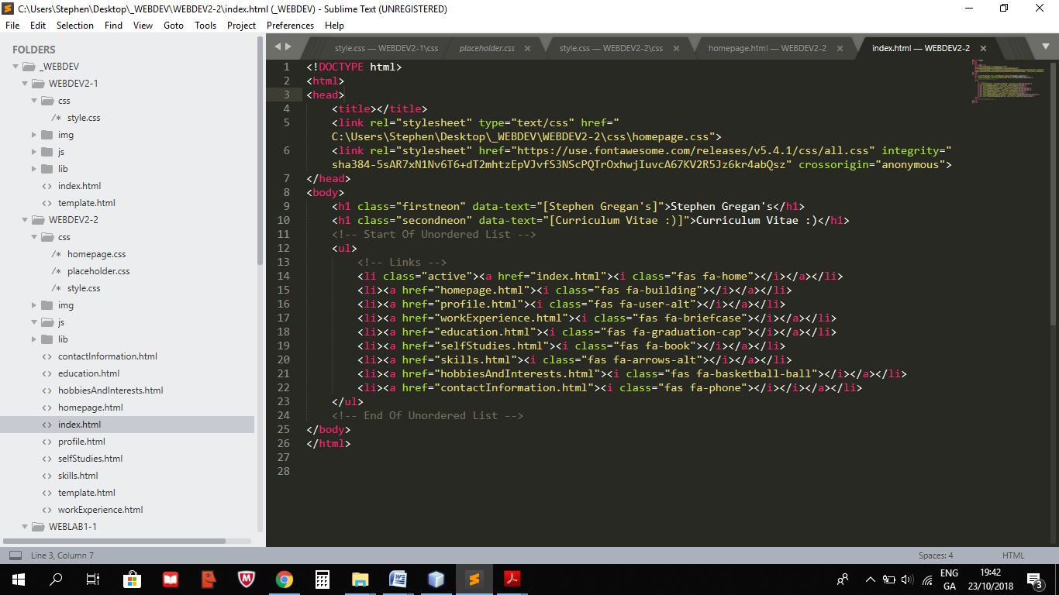

**Homepage.html**

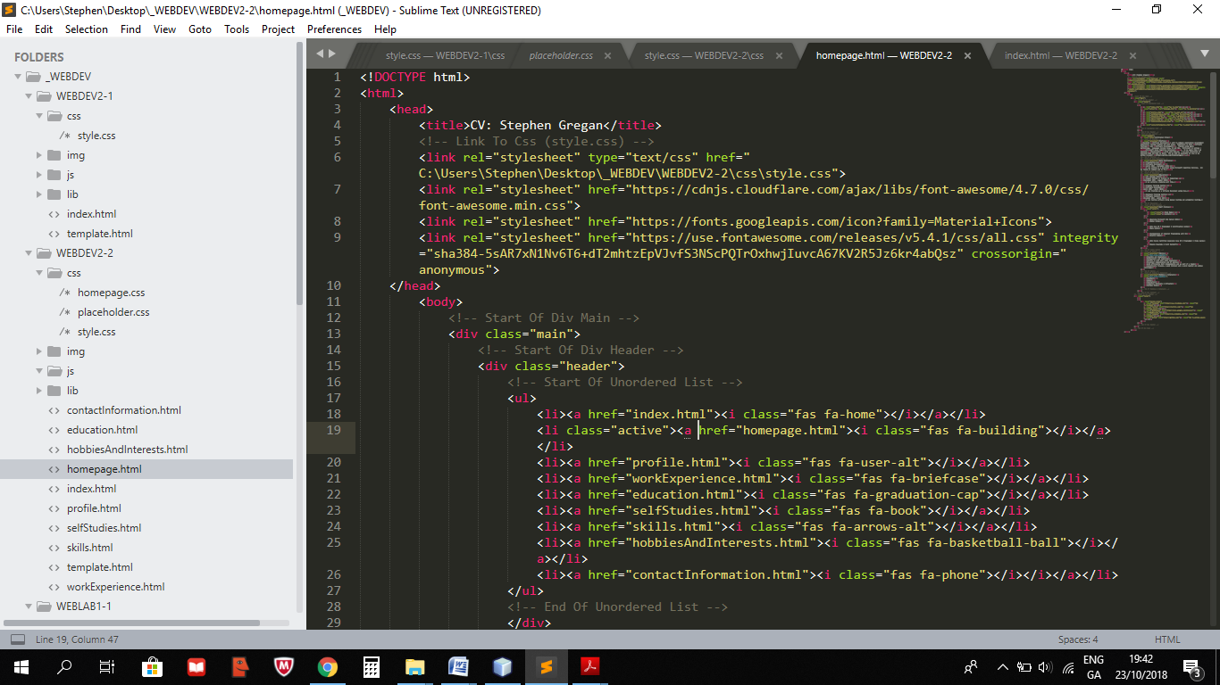

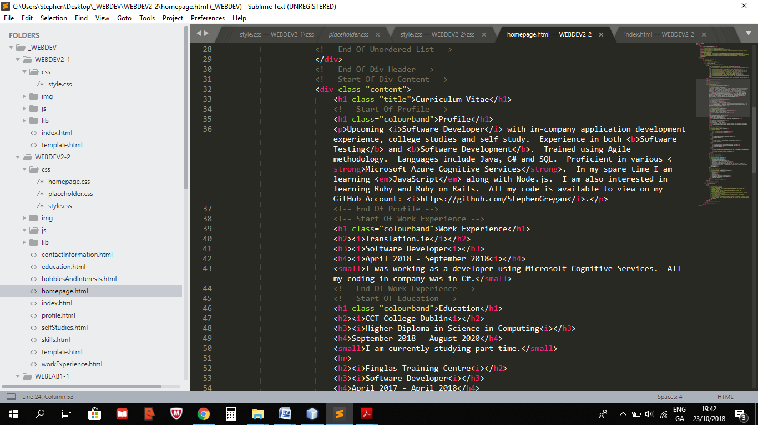

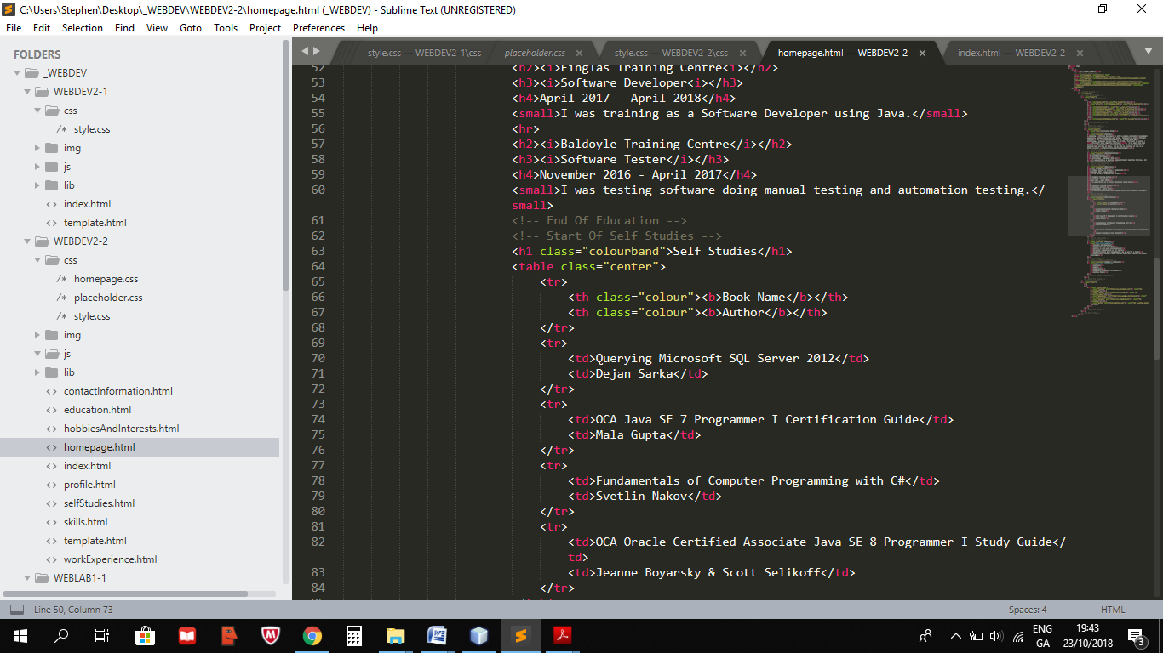

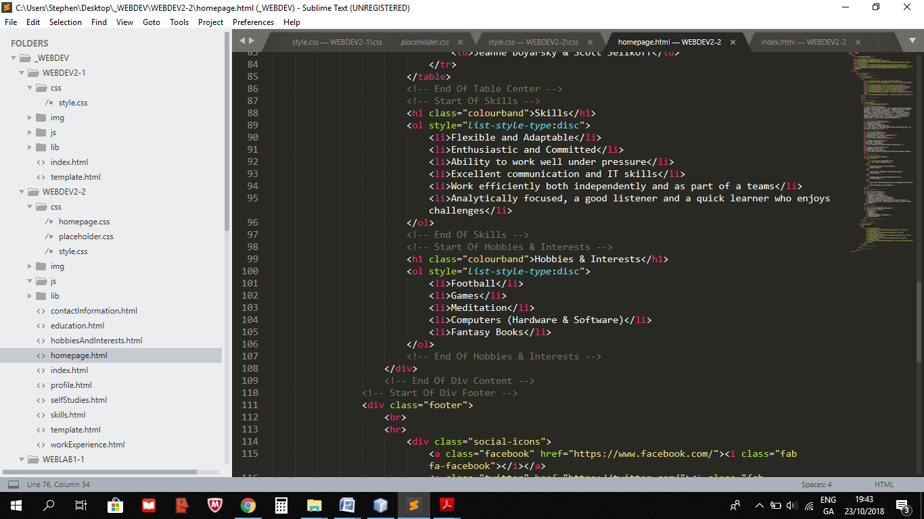

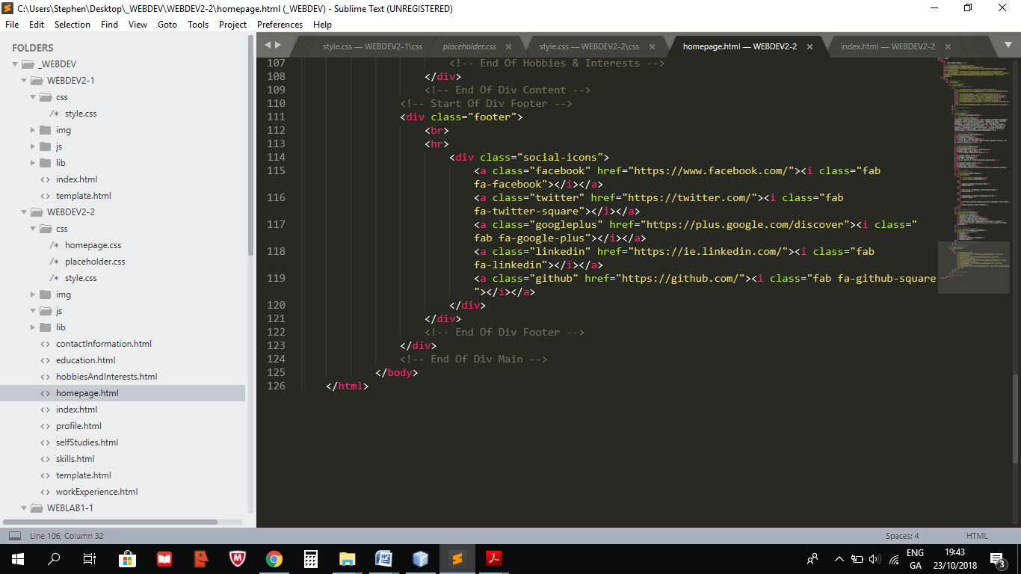

**Profile.html**

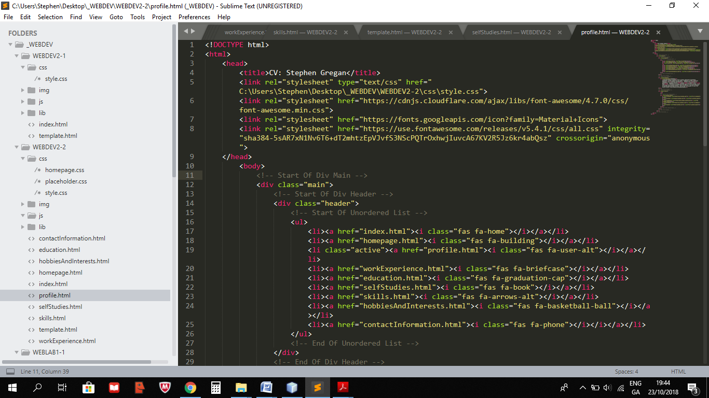

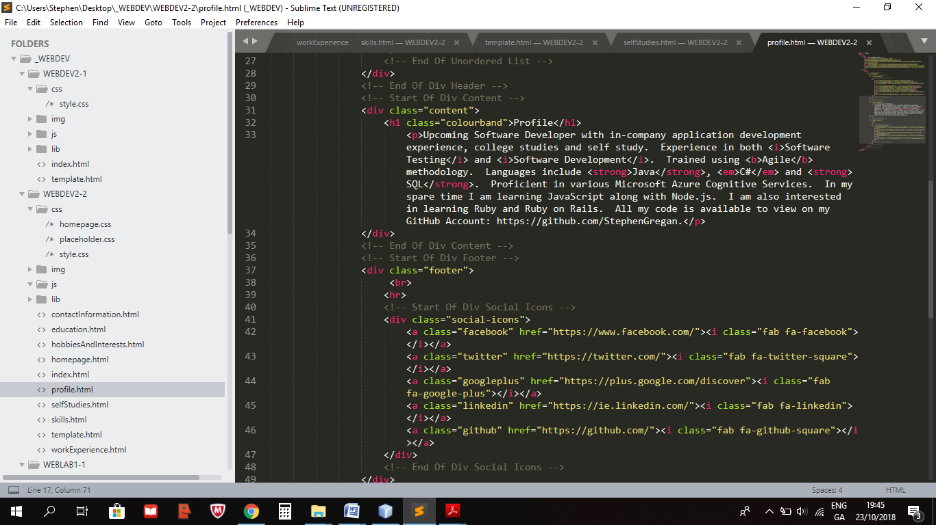

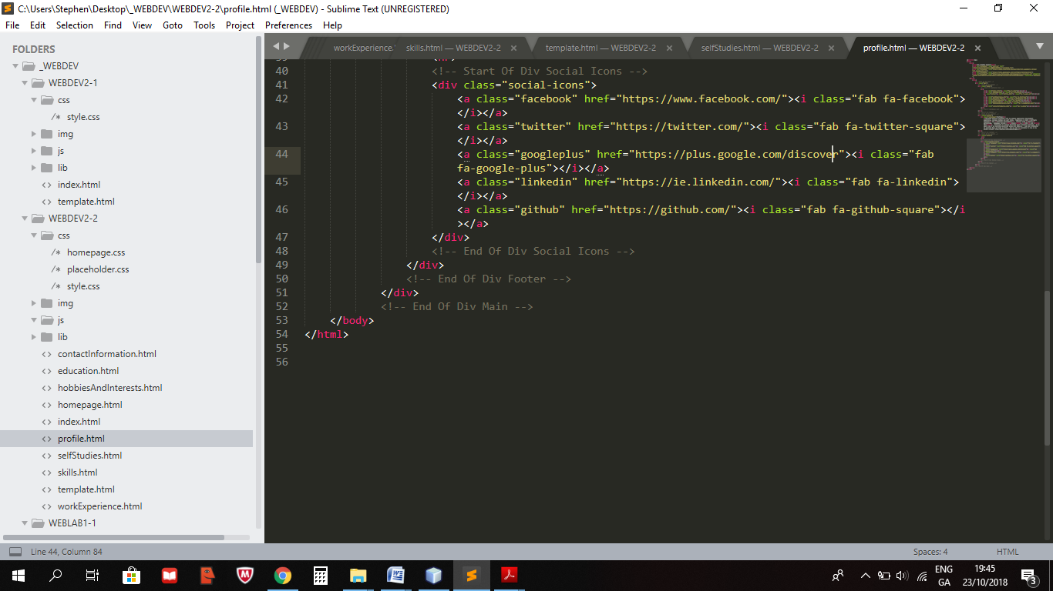

**WorkExperience.html**

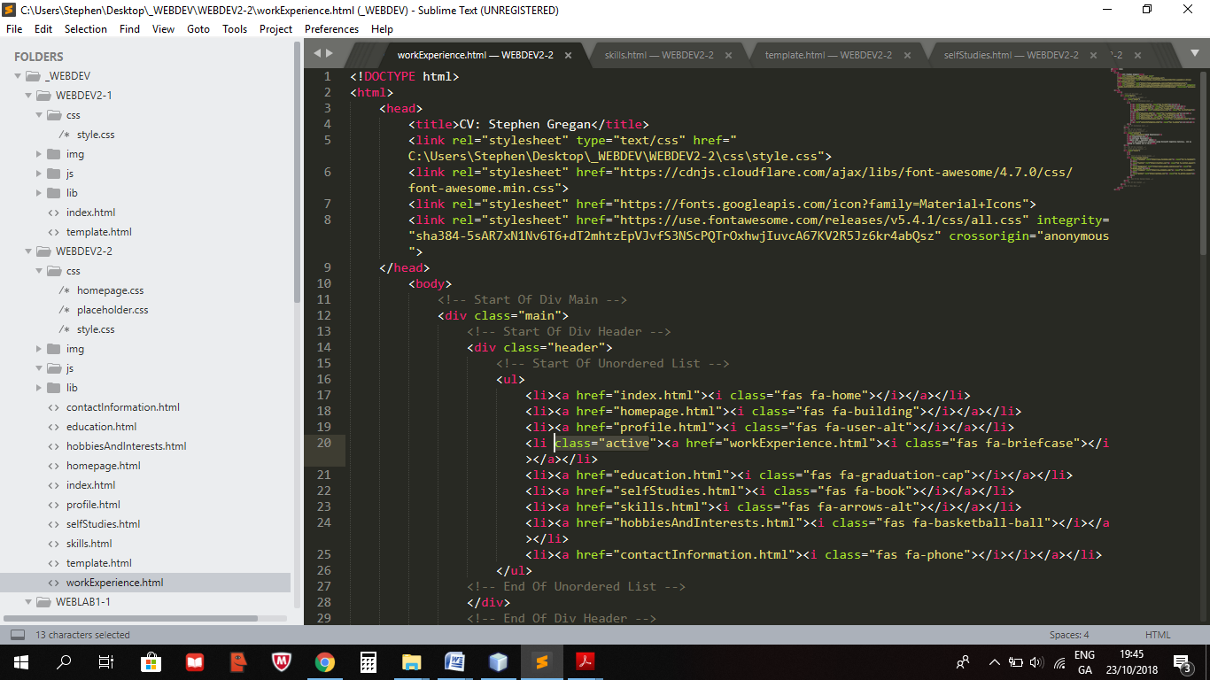

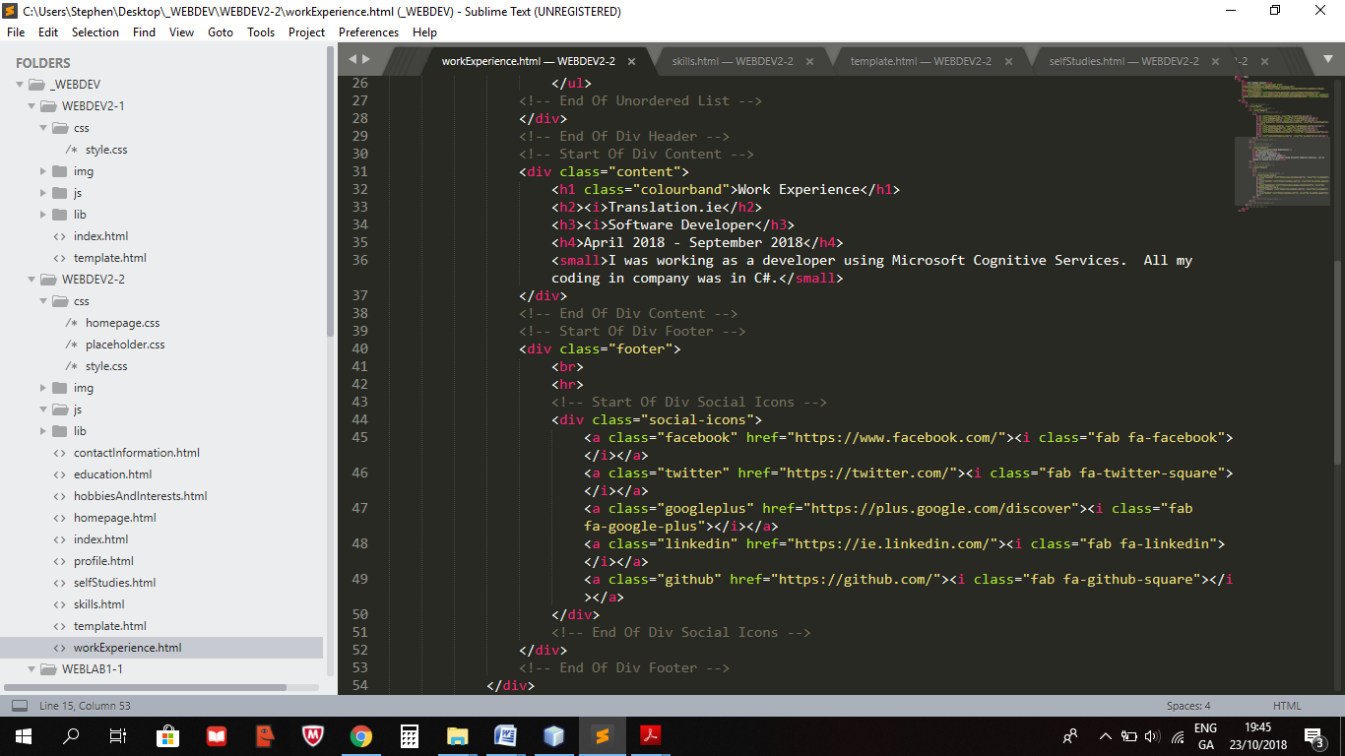

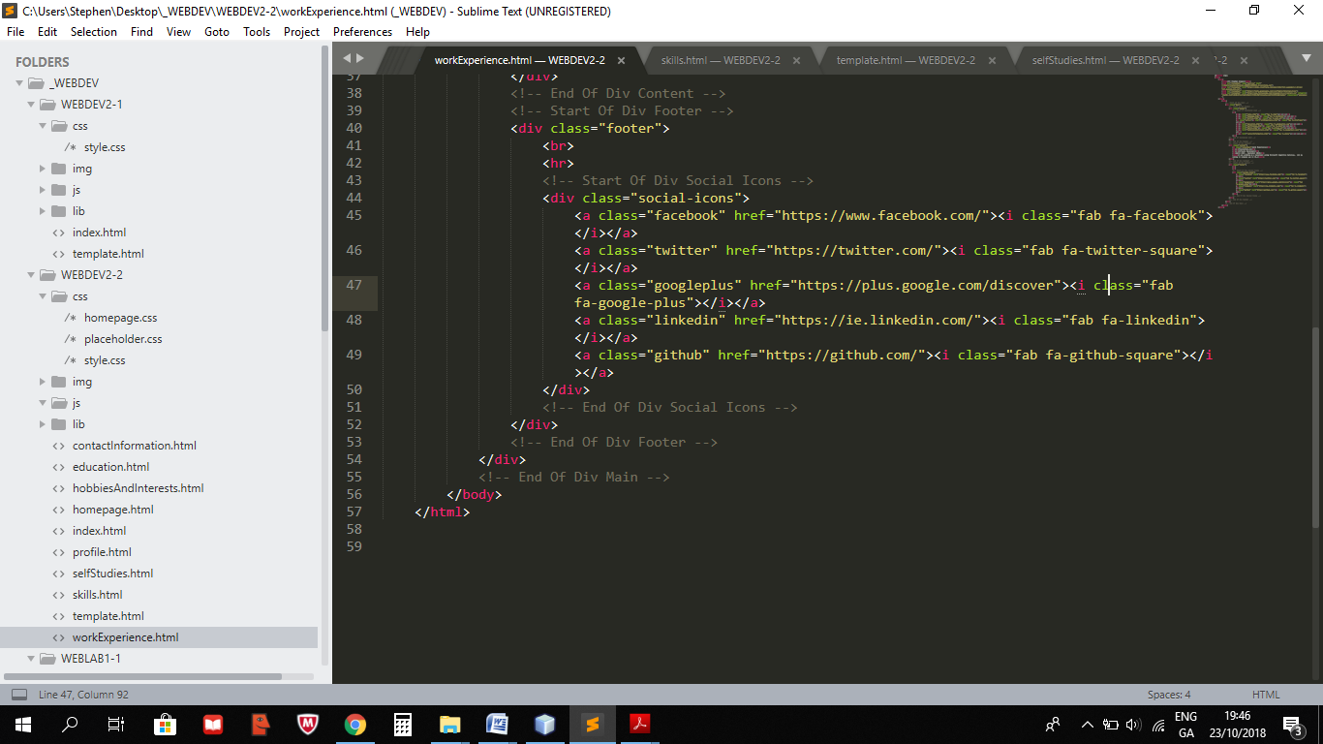

**Education.html**

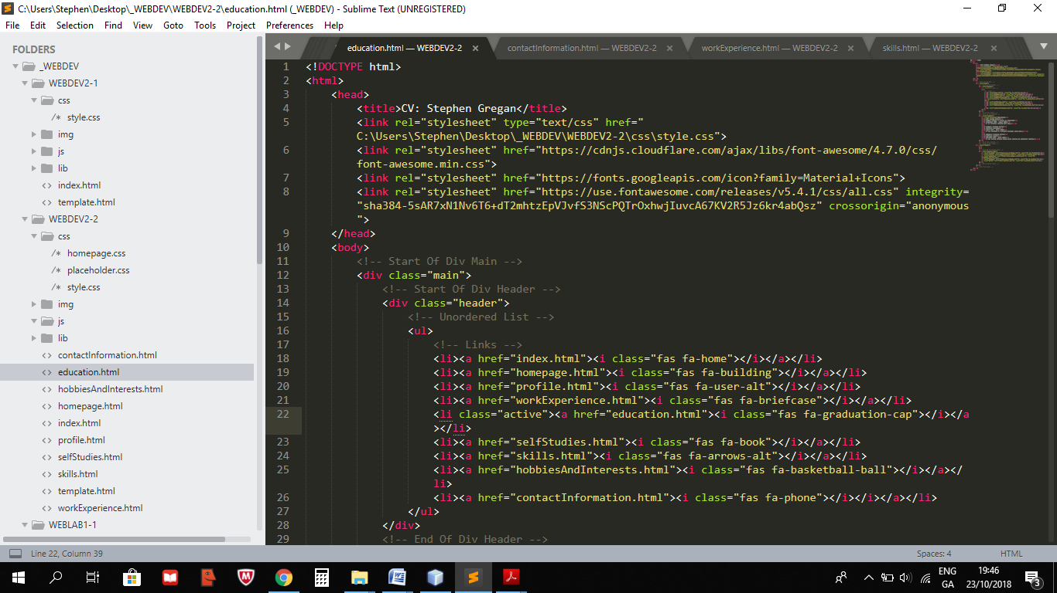

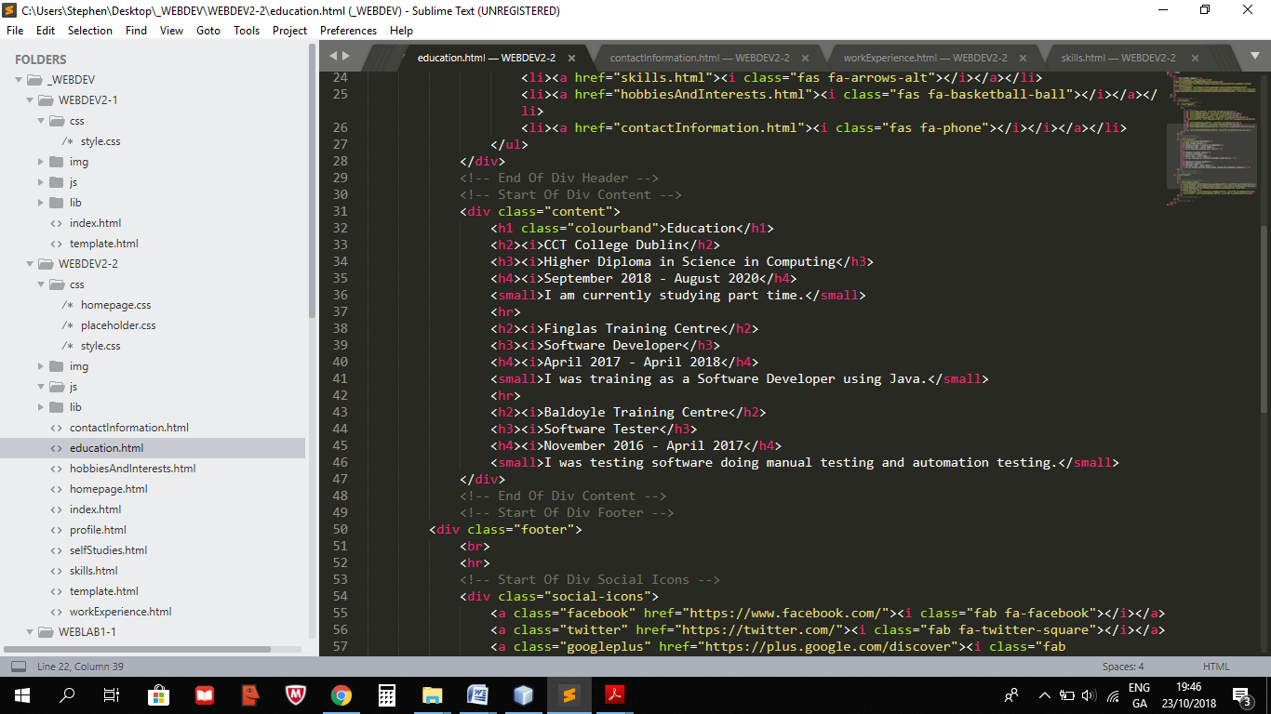

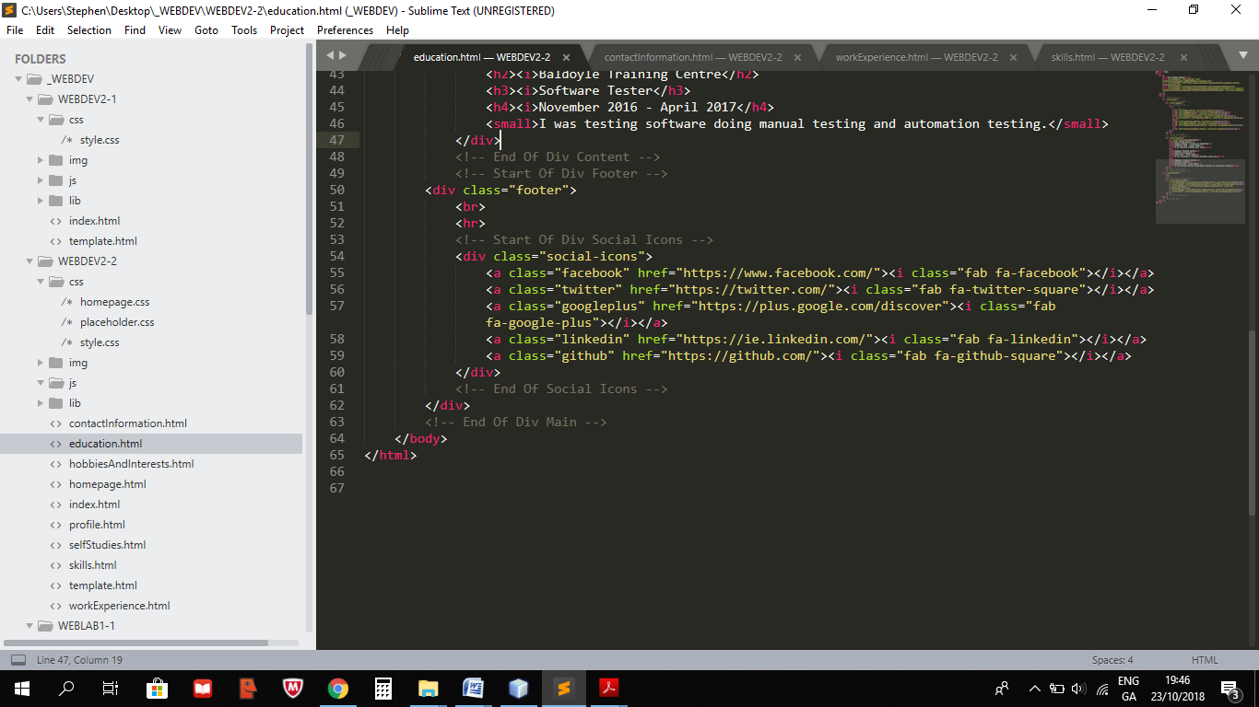

**SelfStudies.html**

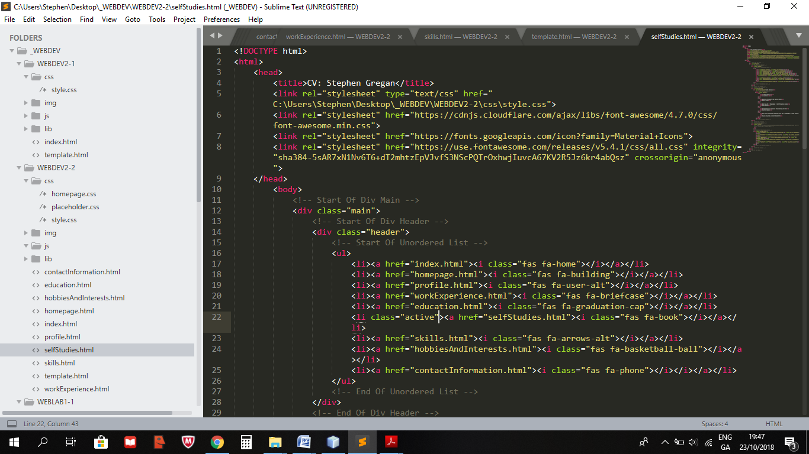

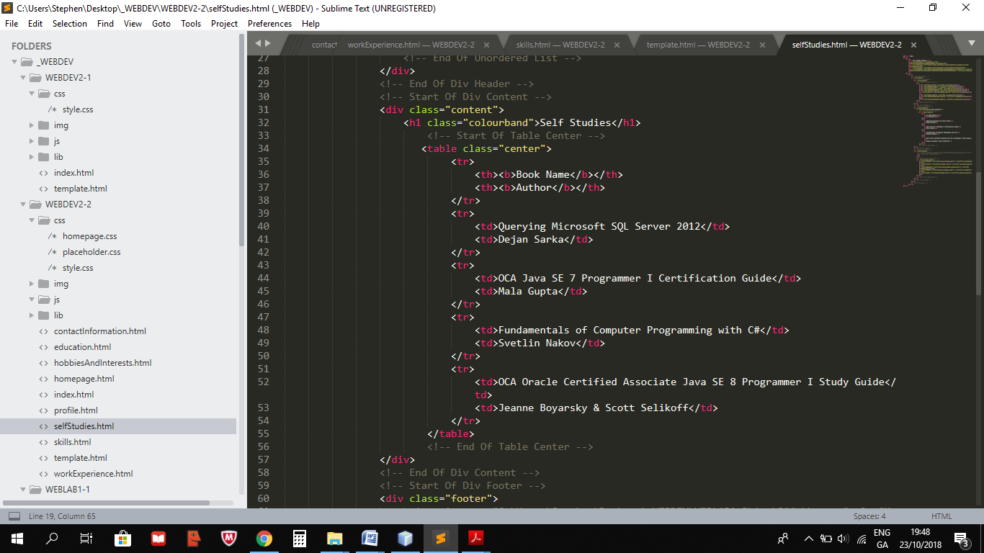

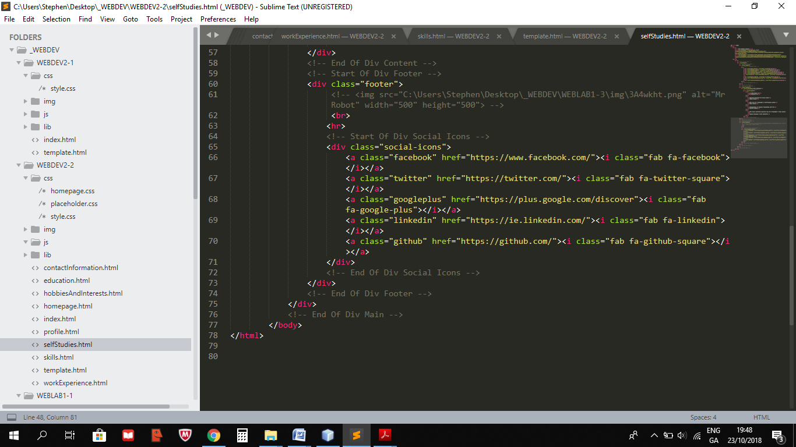

**Skills.html**

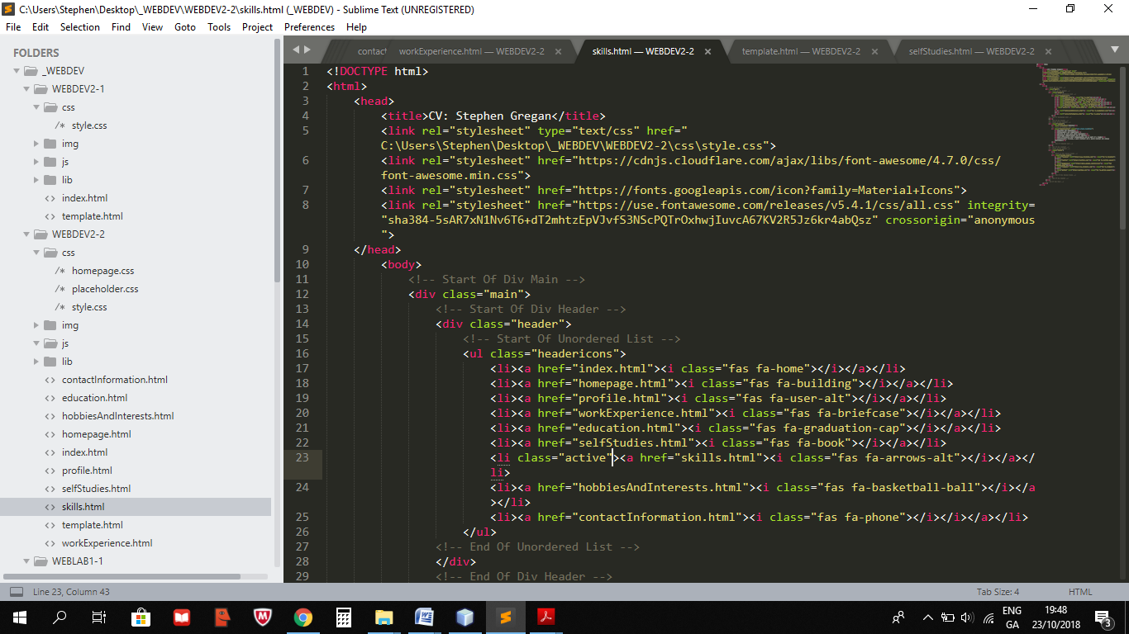

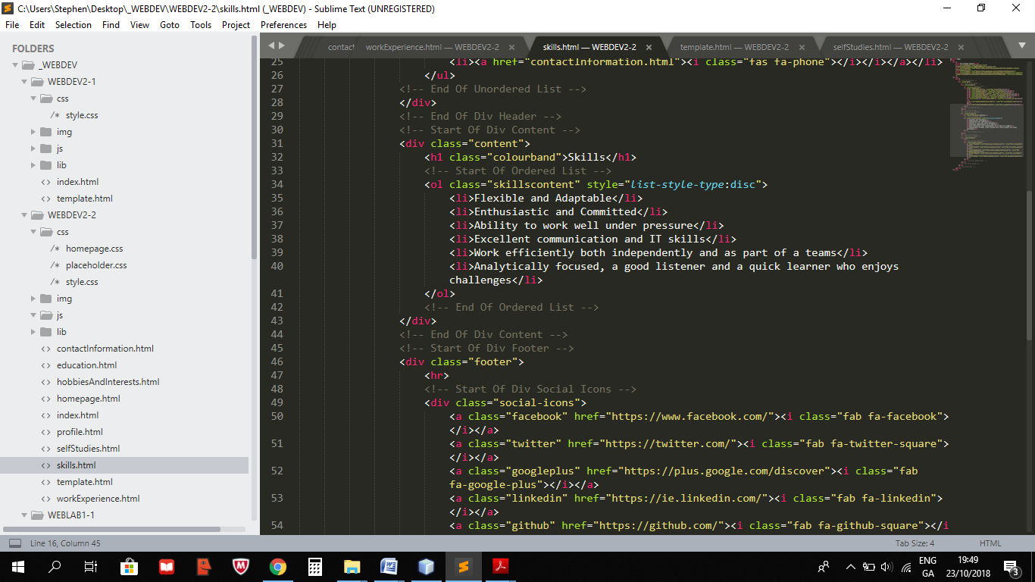

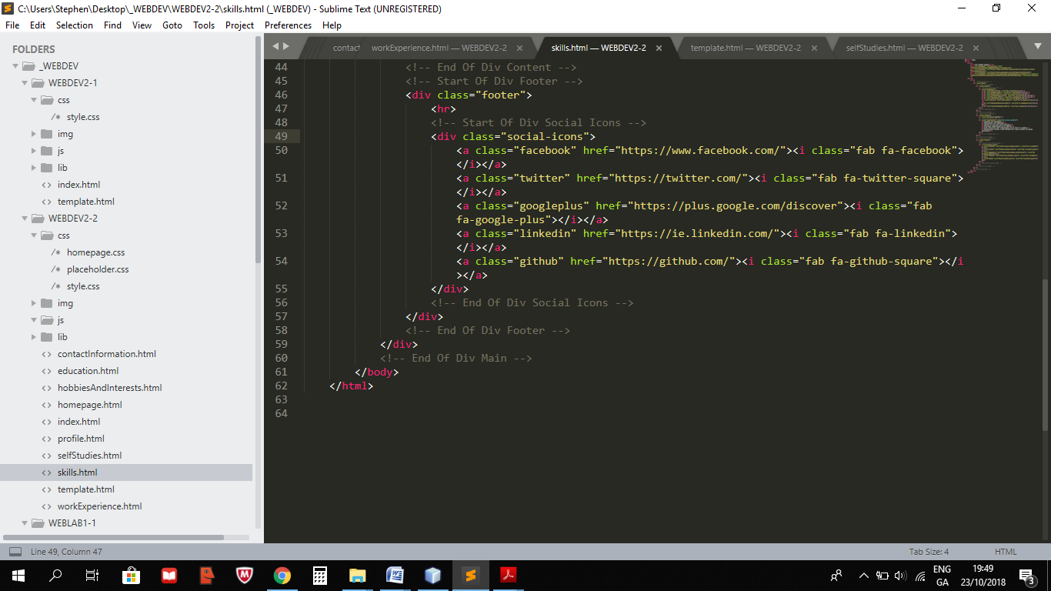

**HobbiesAndInterests.html**

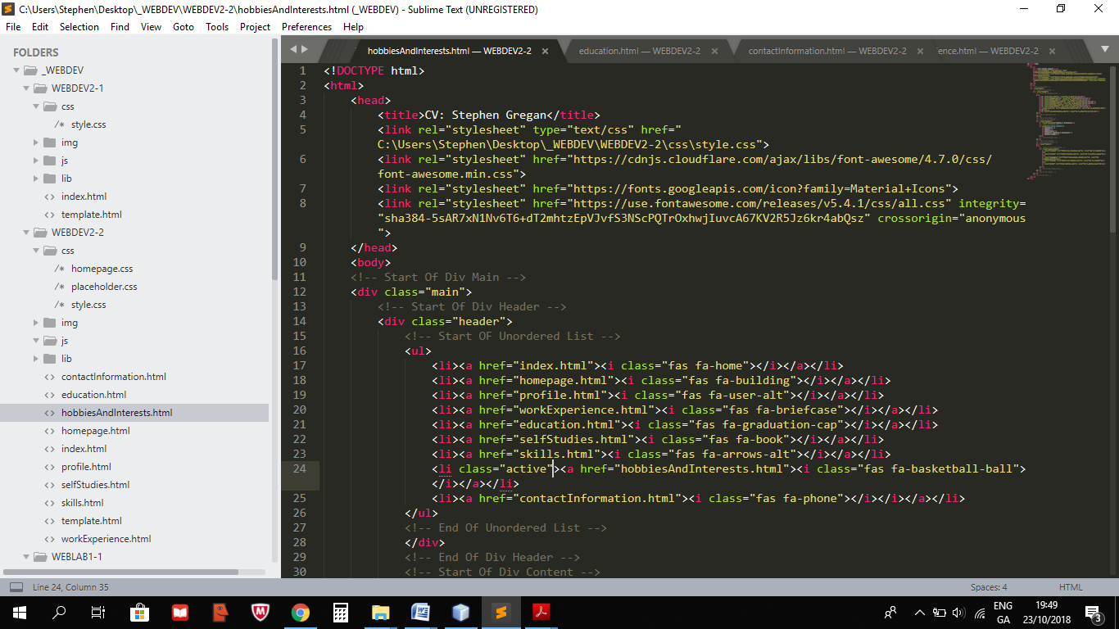

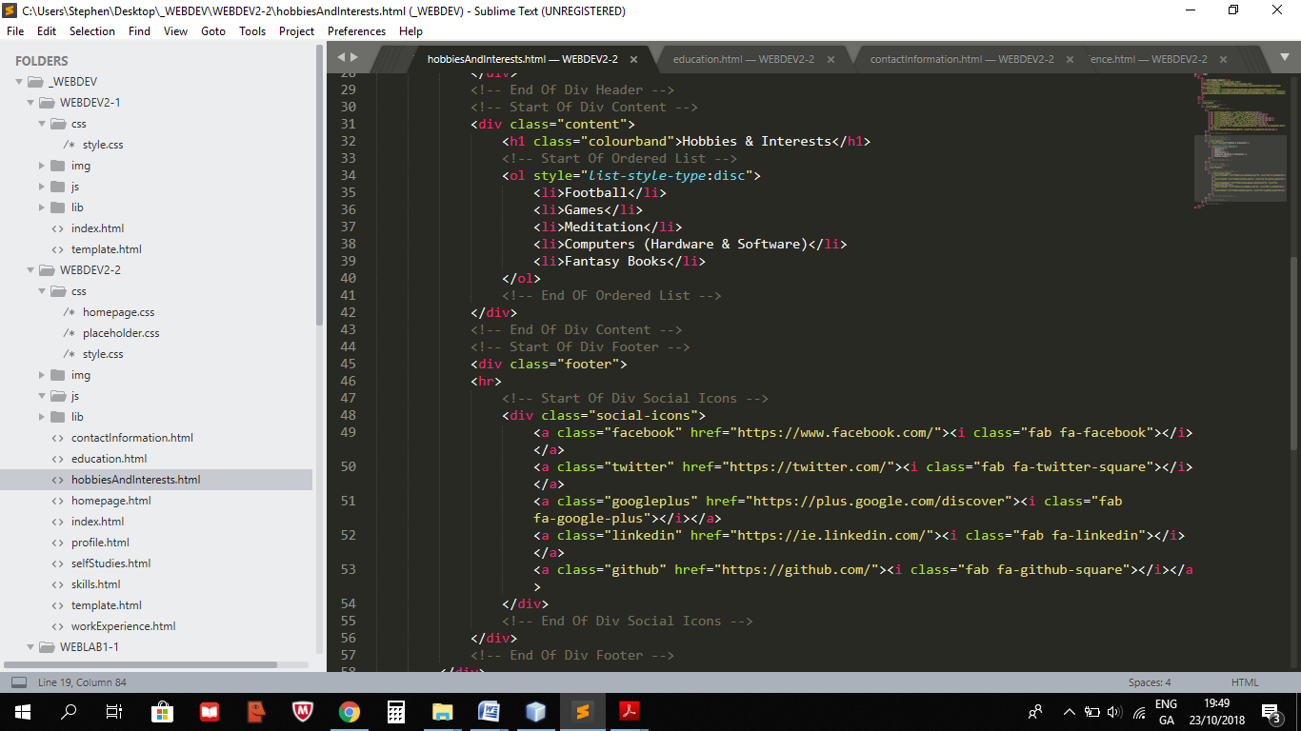

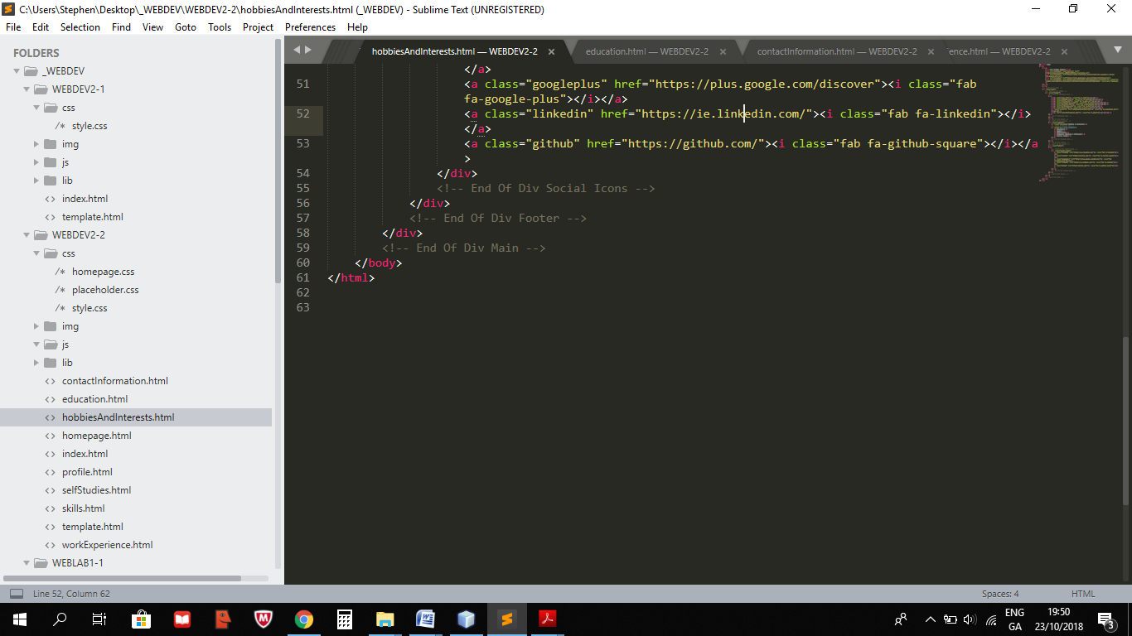

**ContactInformation.html**

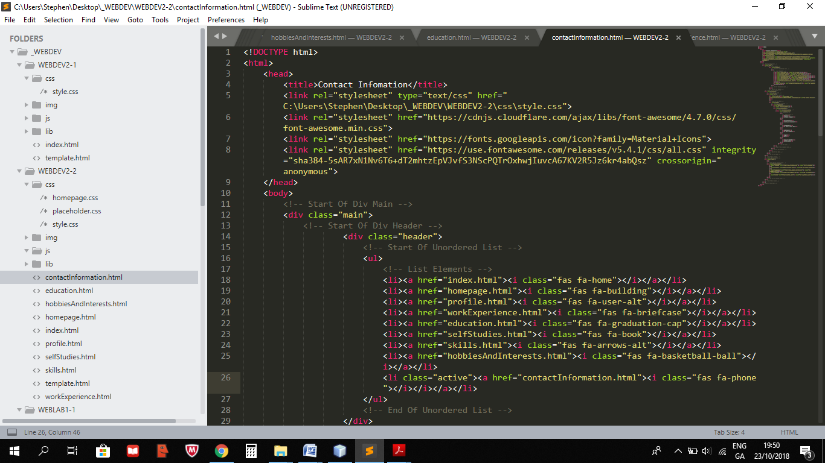

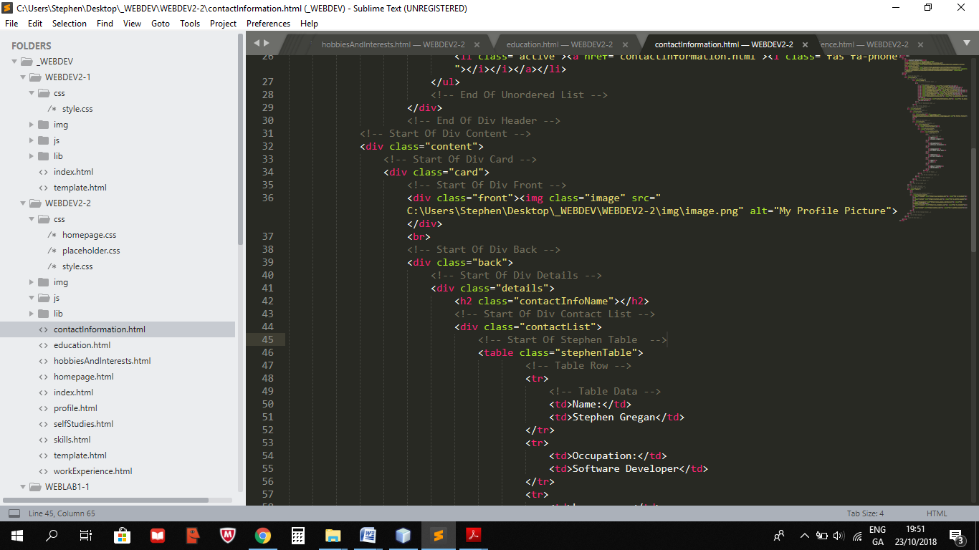

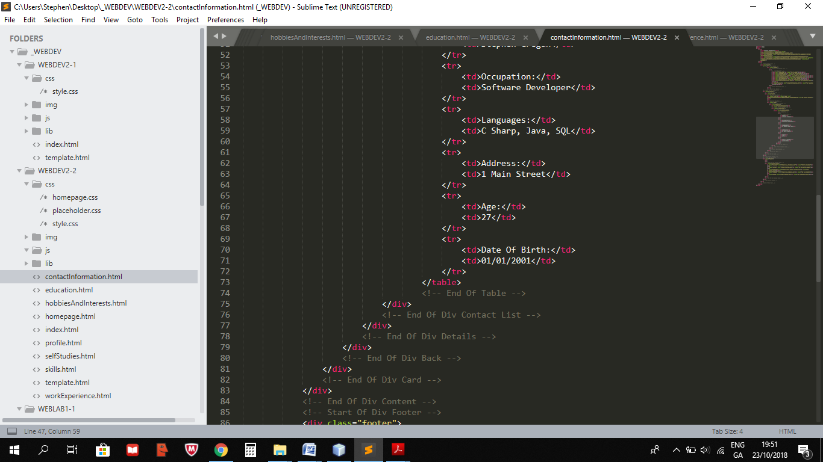

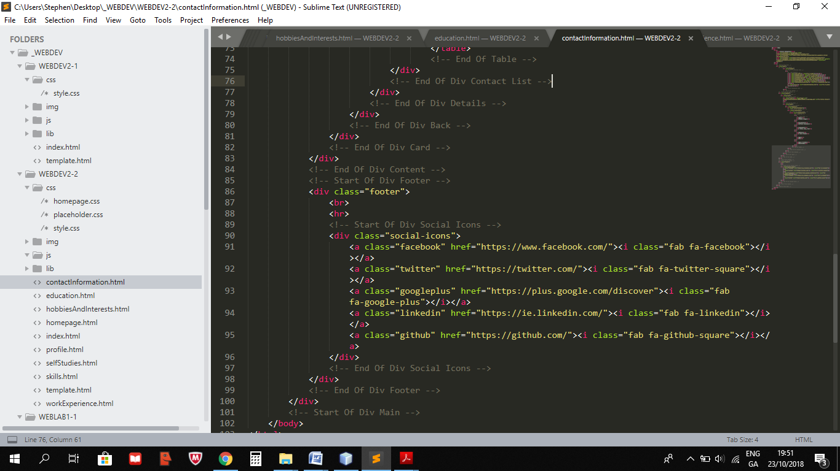

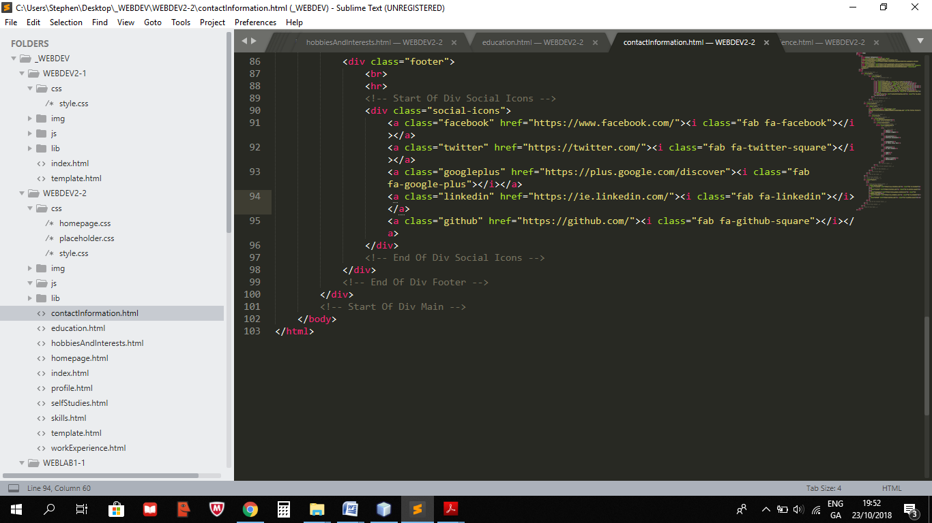

**Style.css**

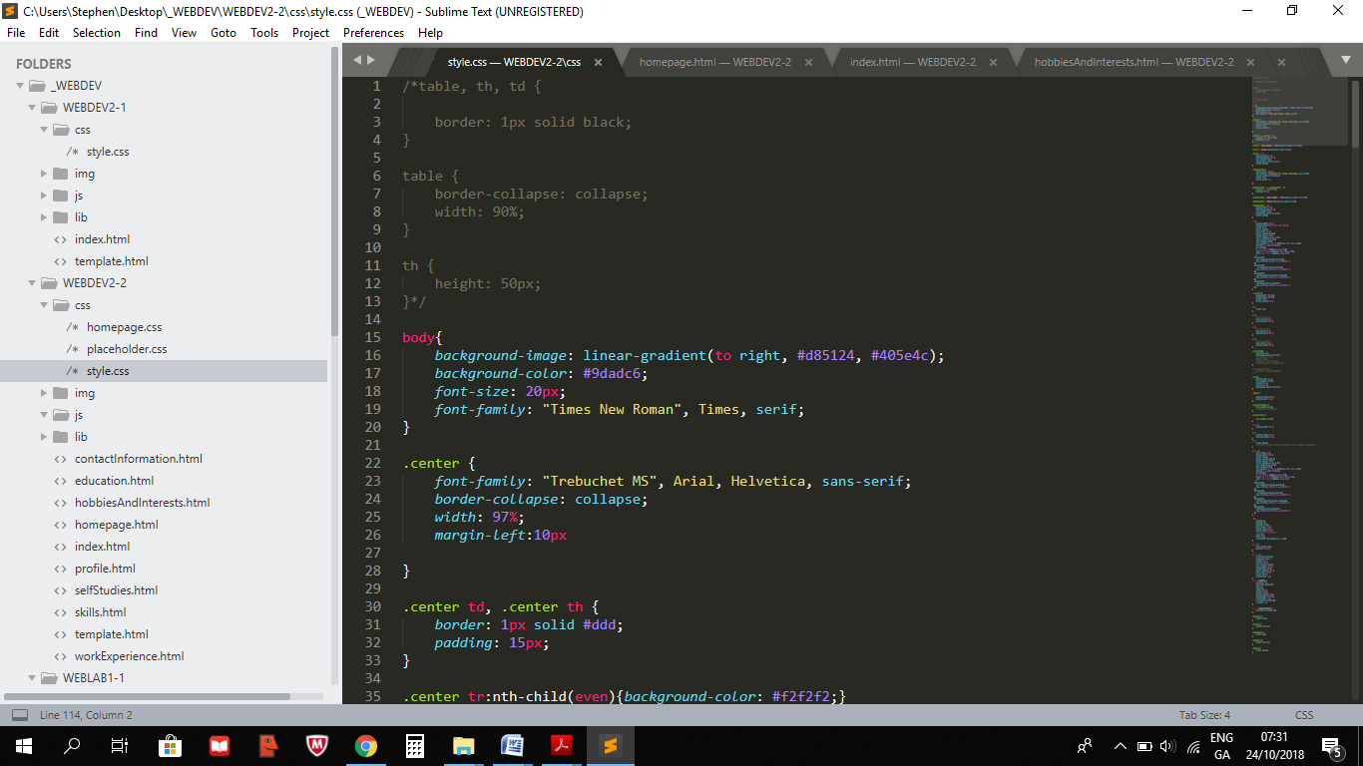

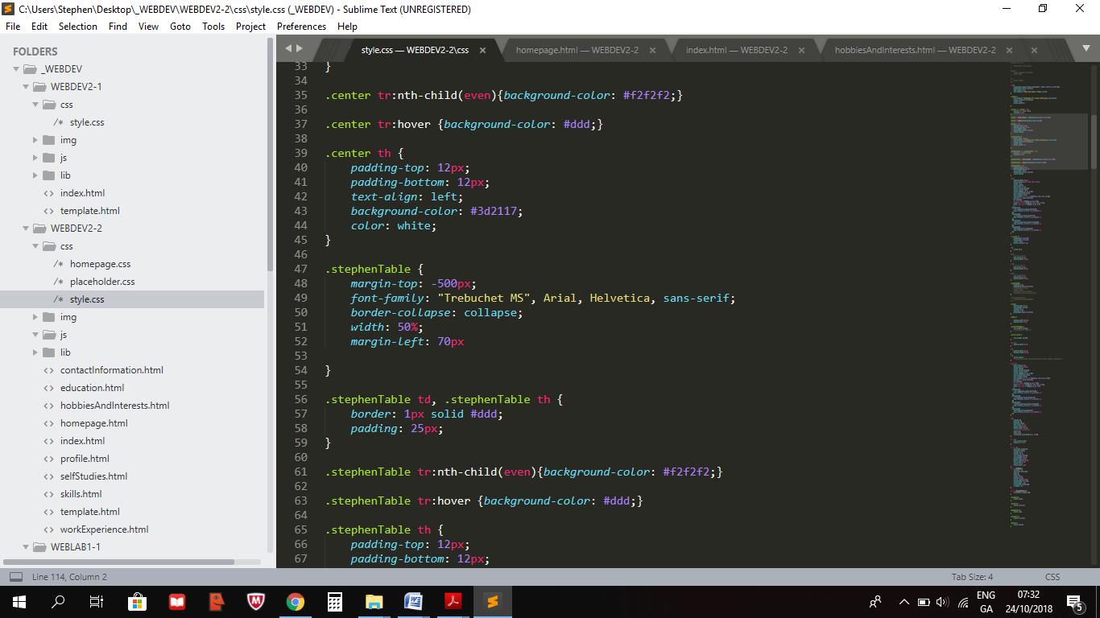

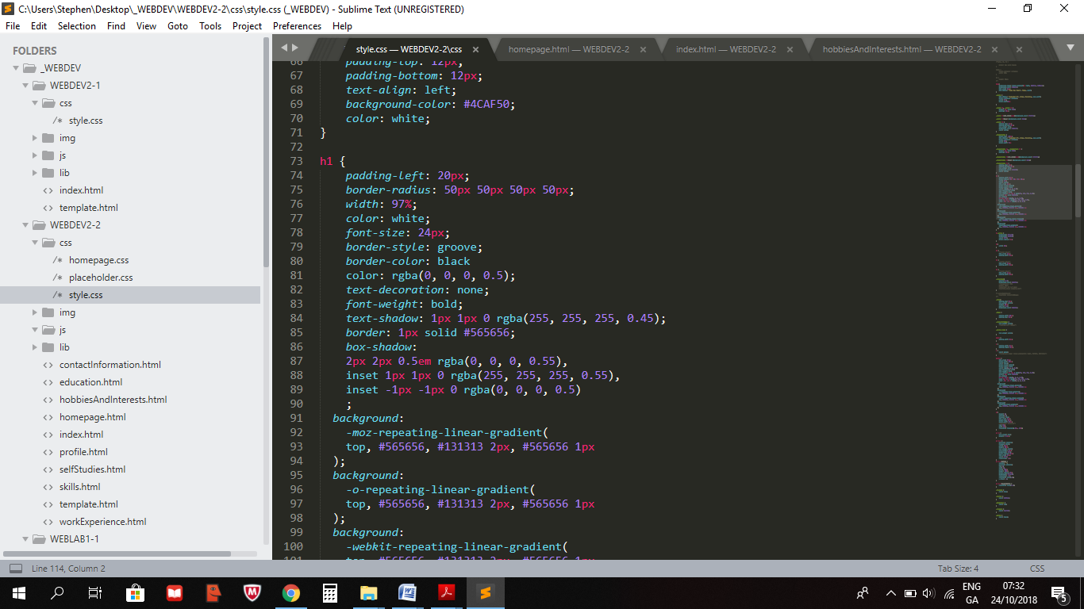

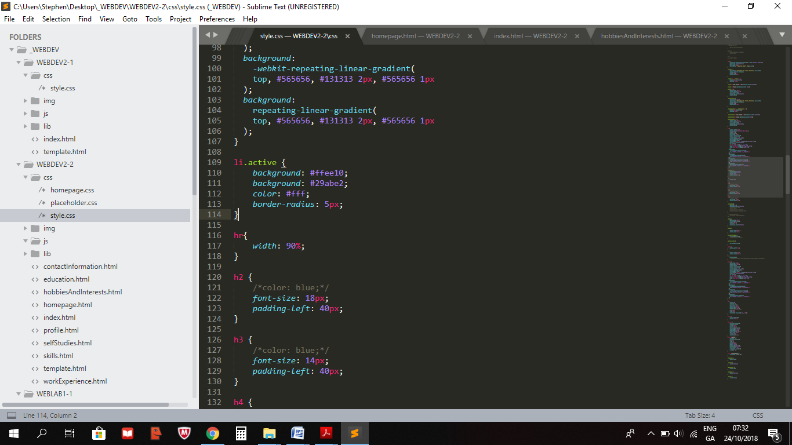

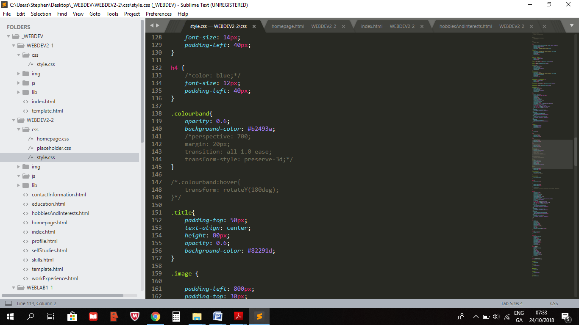

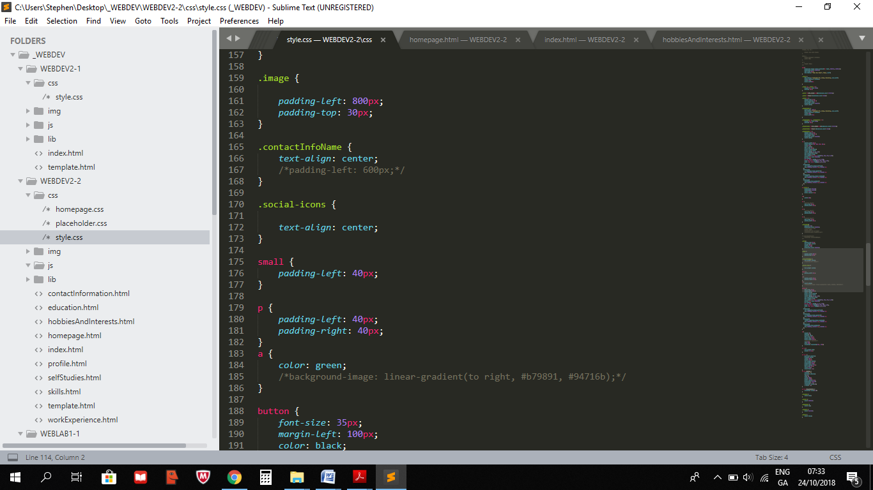

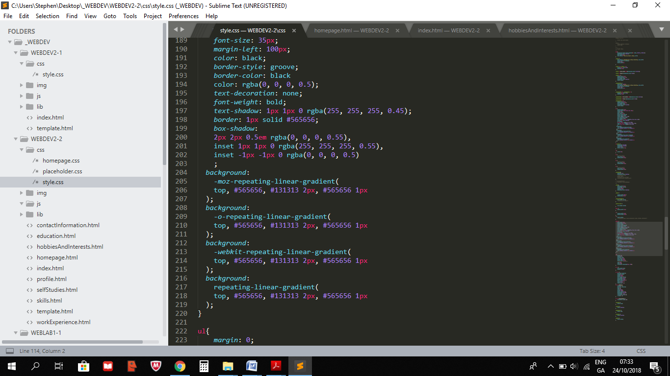

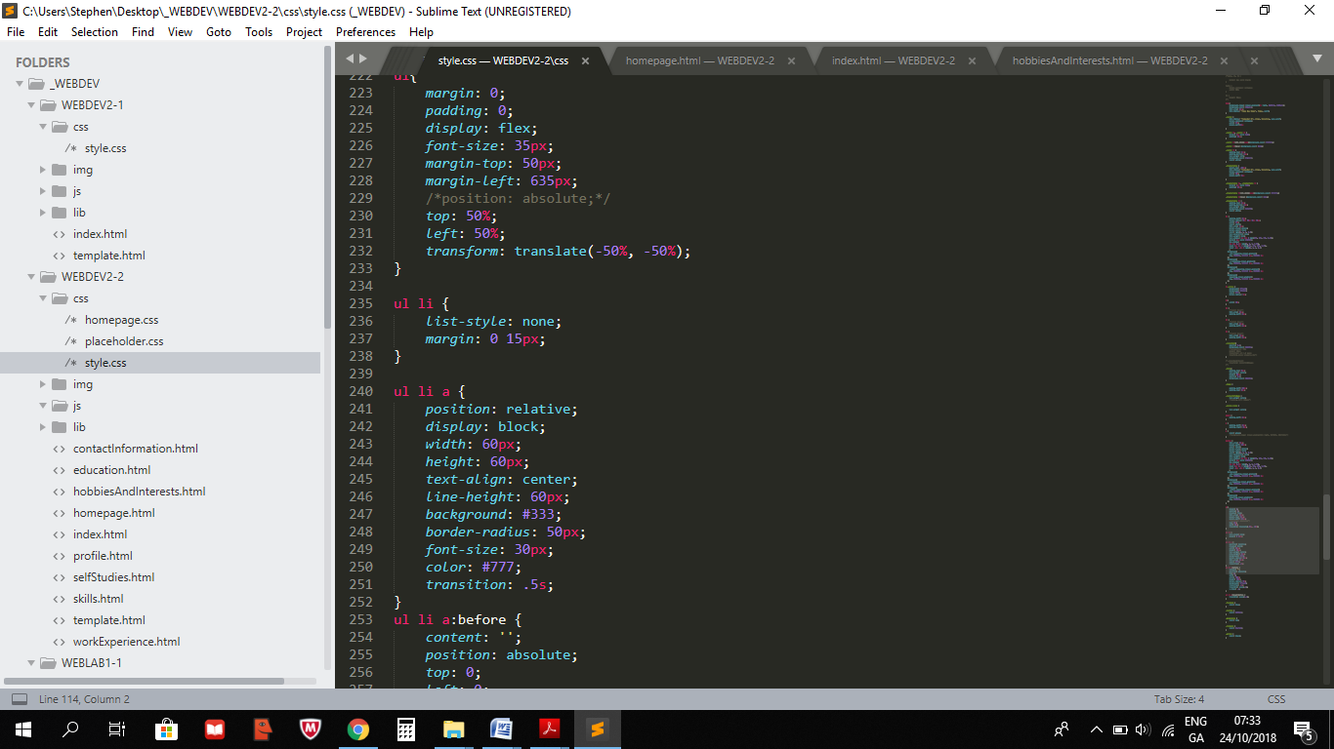

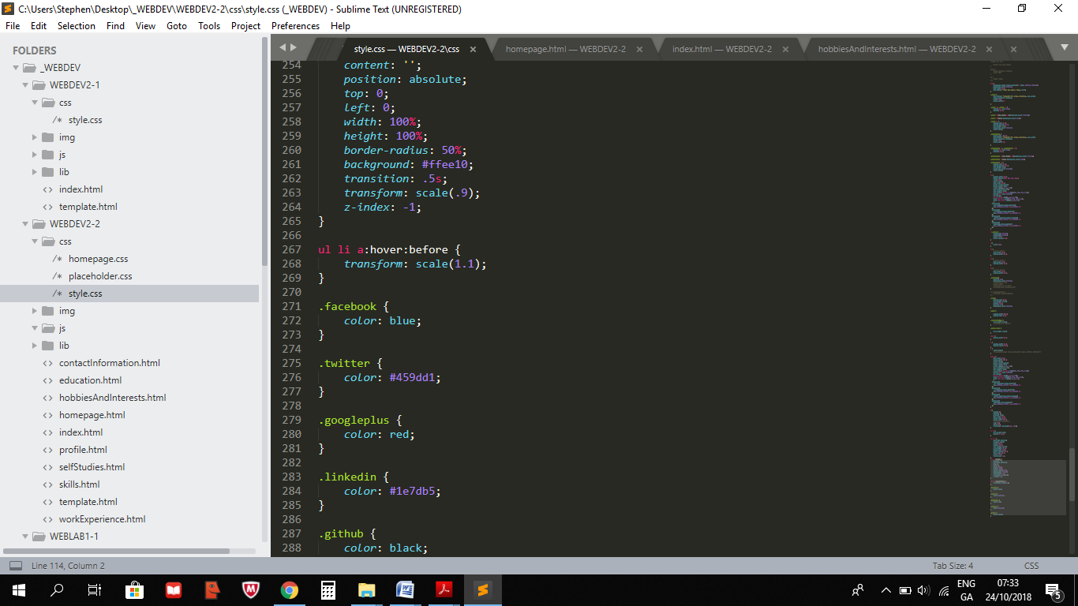

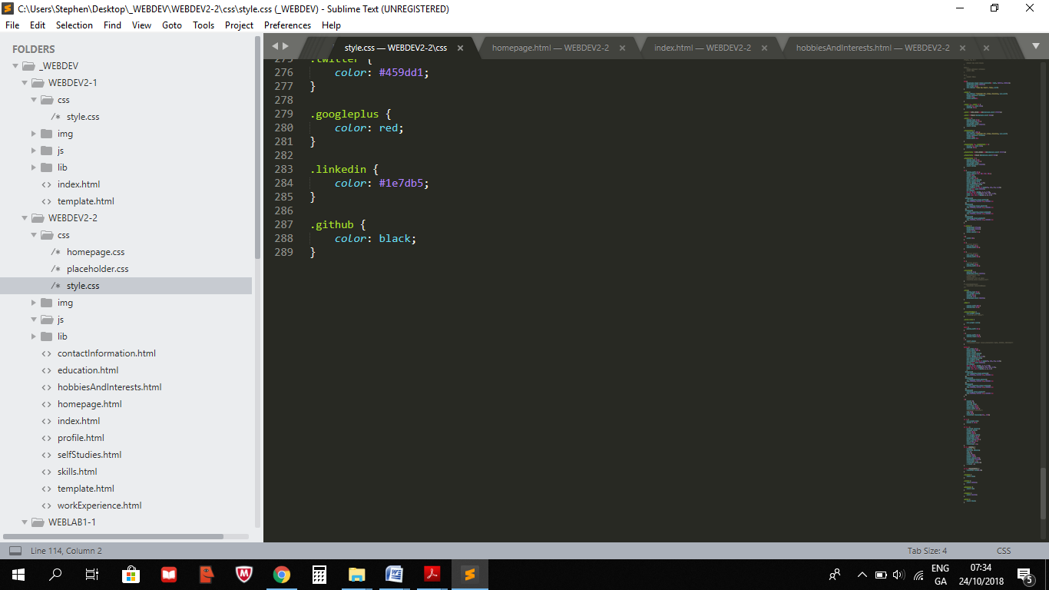

**Homepage.css**

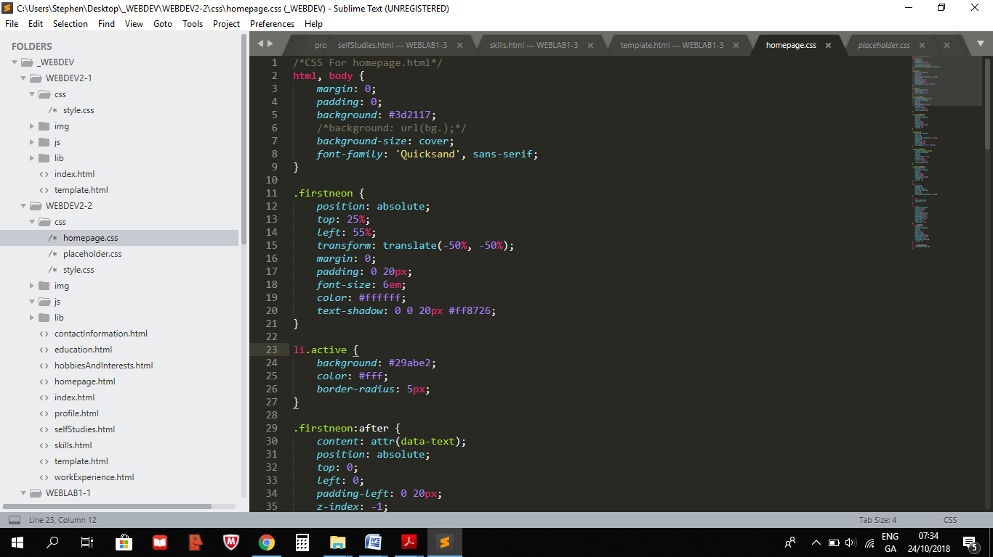

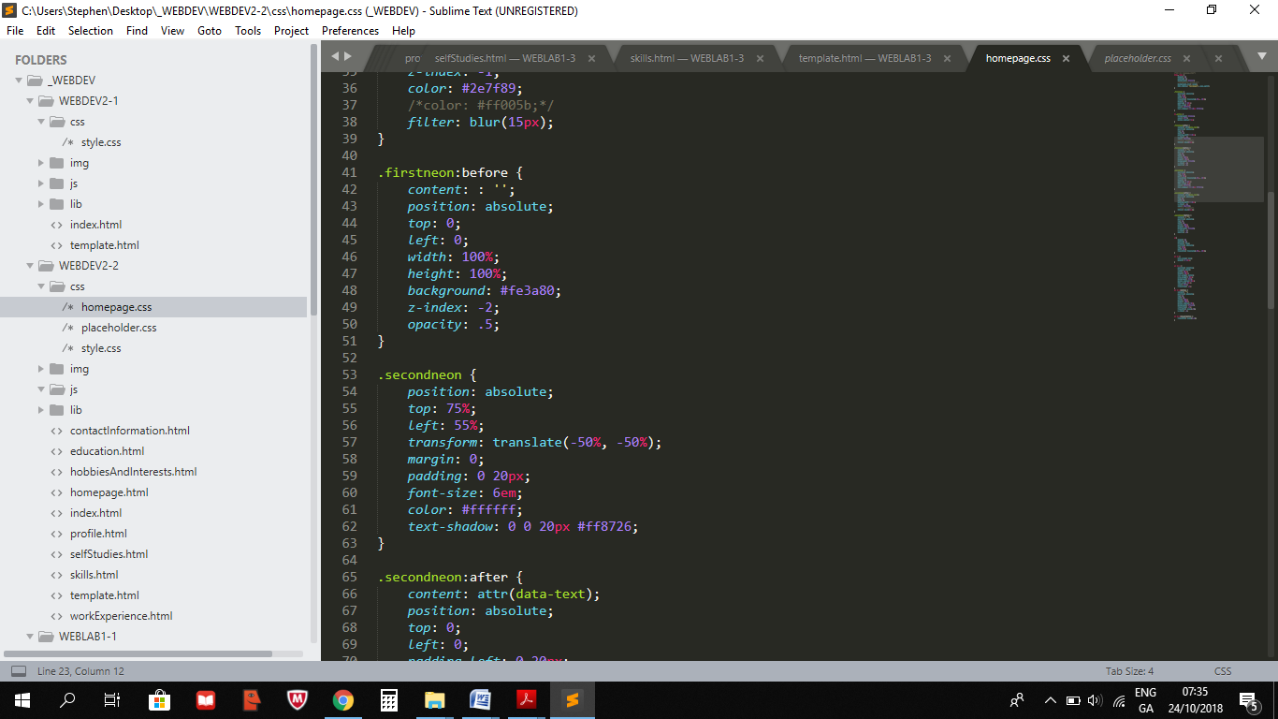

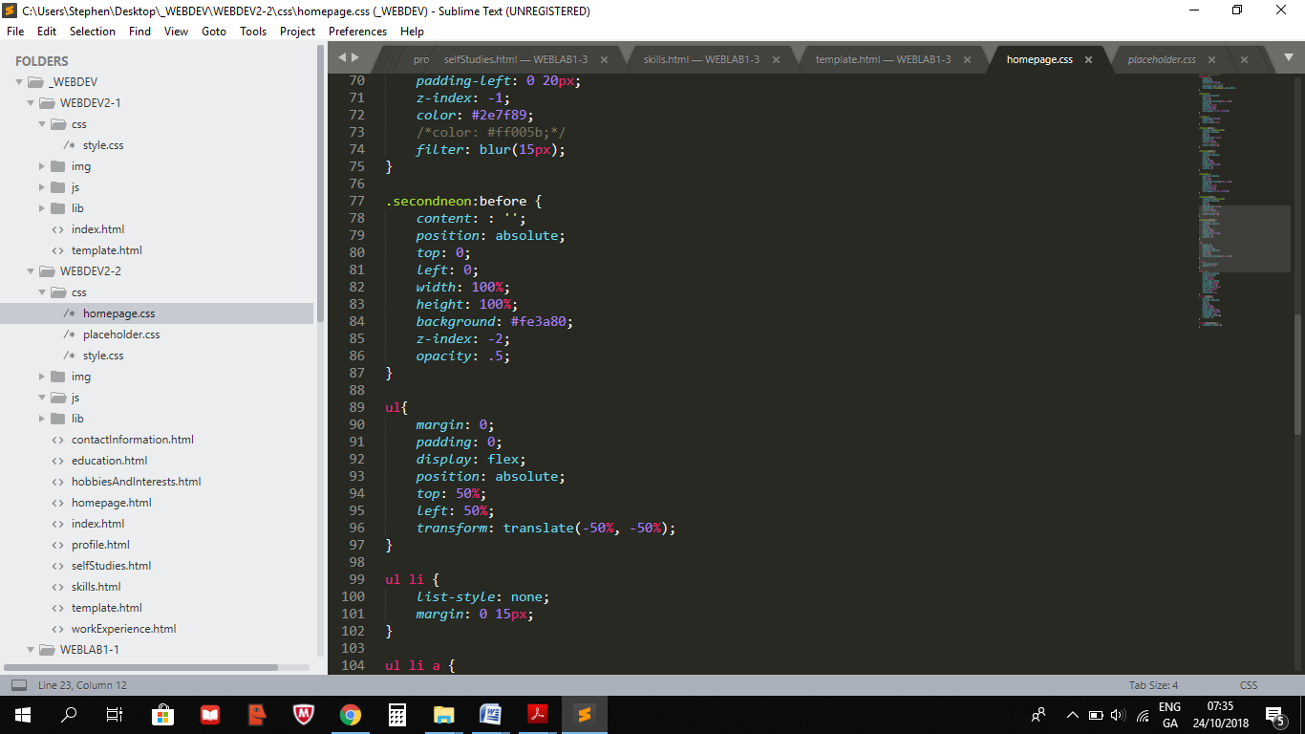

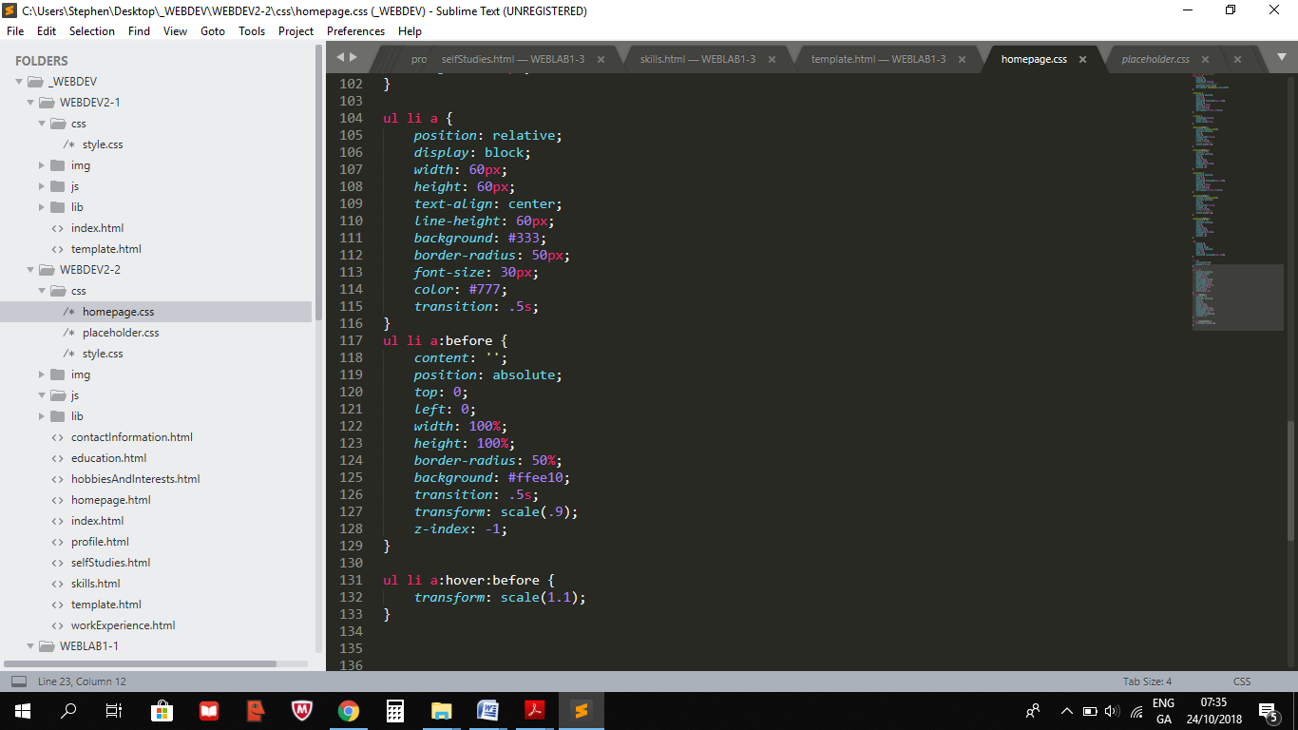

## Screens

**Index.html**

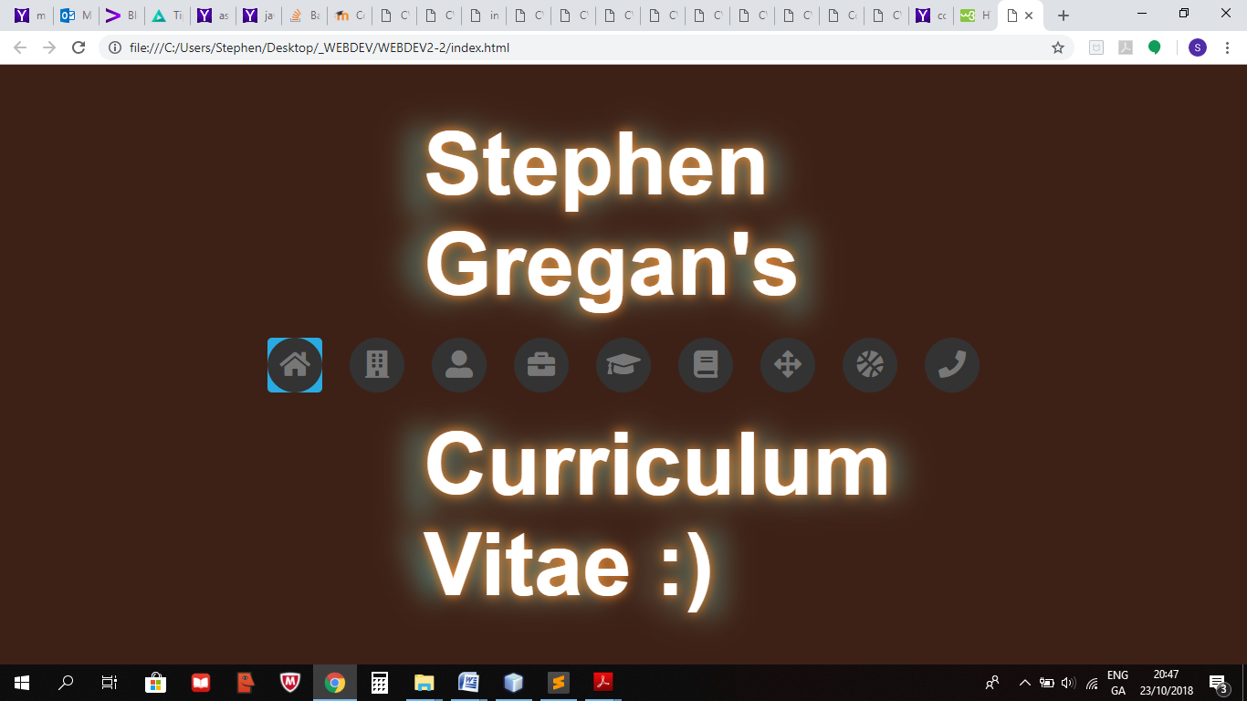

**Homepage.html**

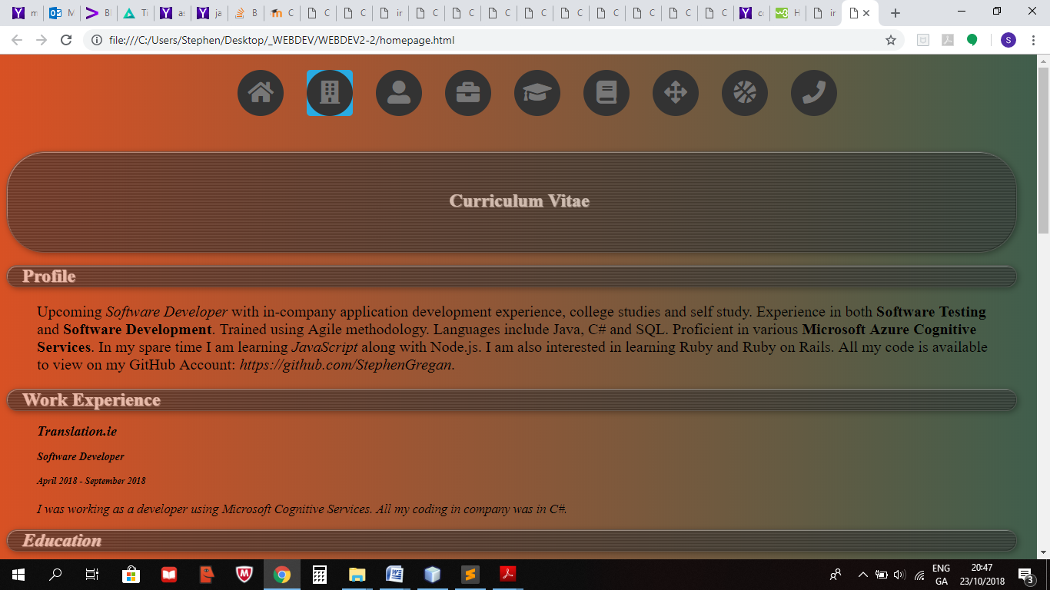

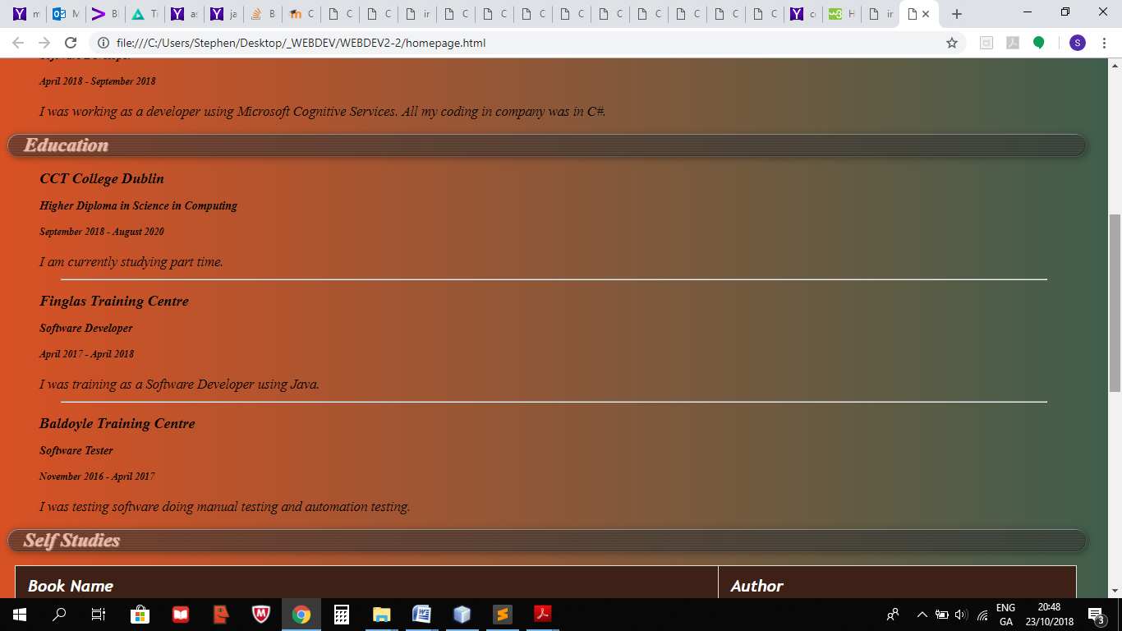

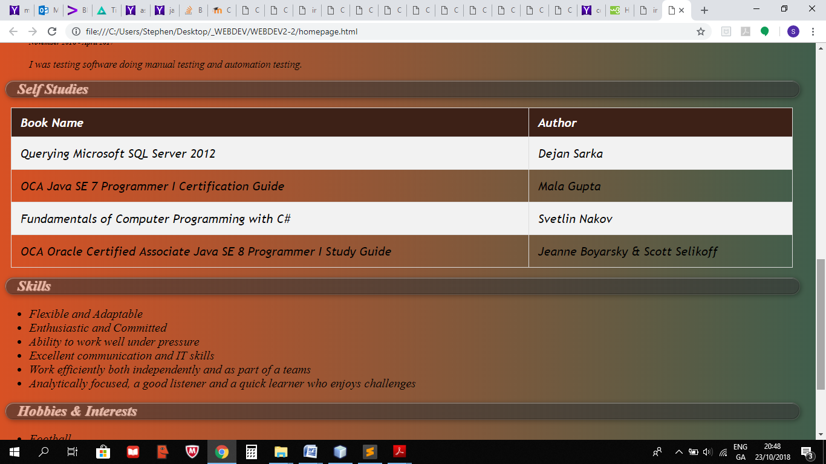

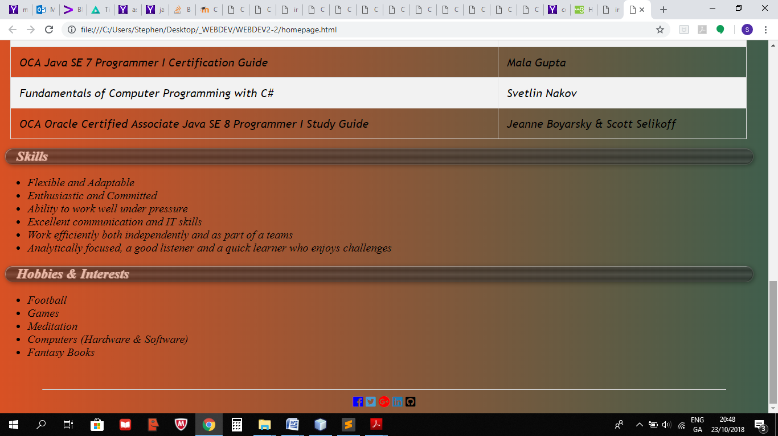

**Profile.html**

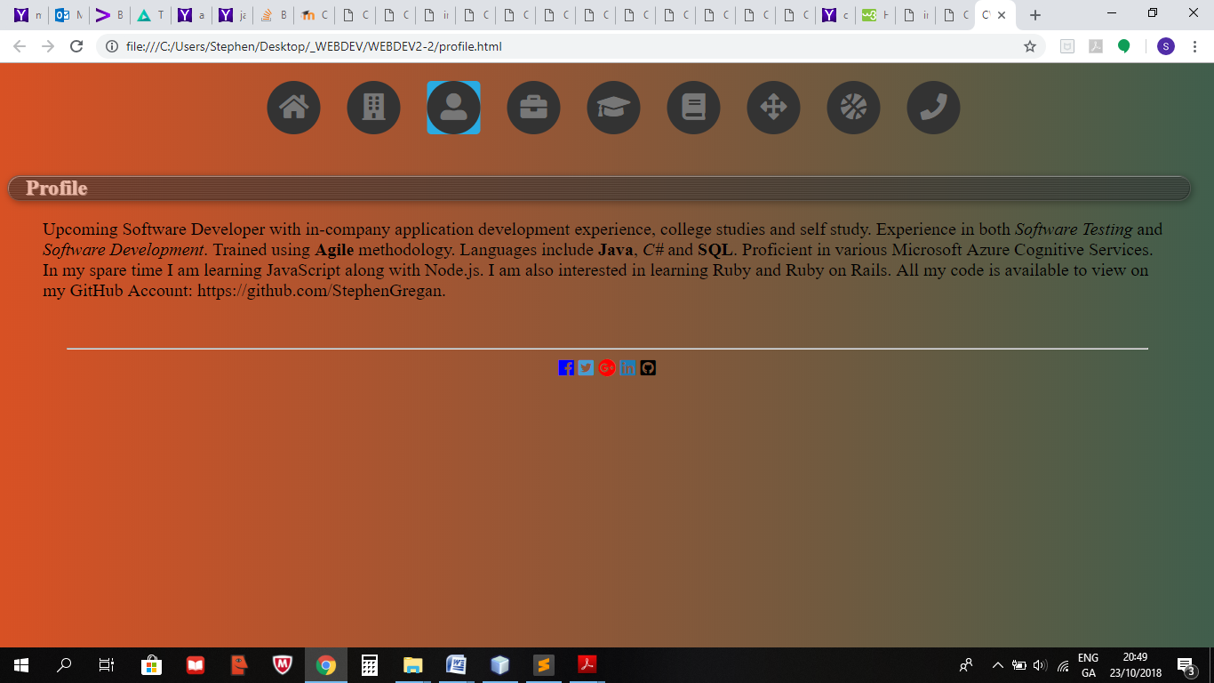

**WorkExperience.html**

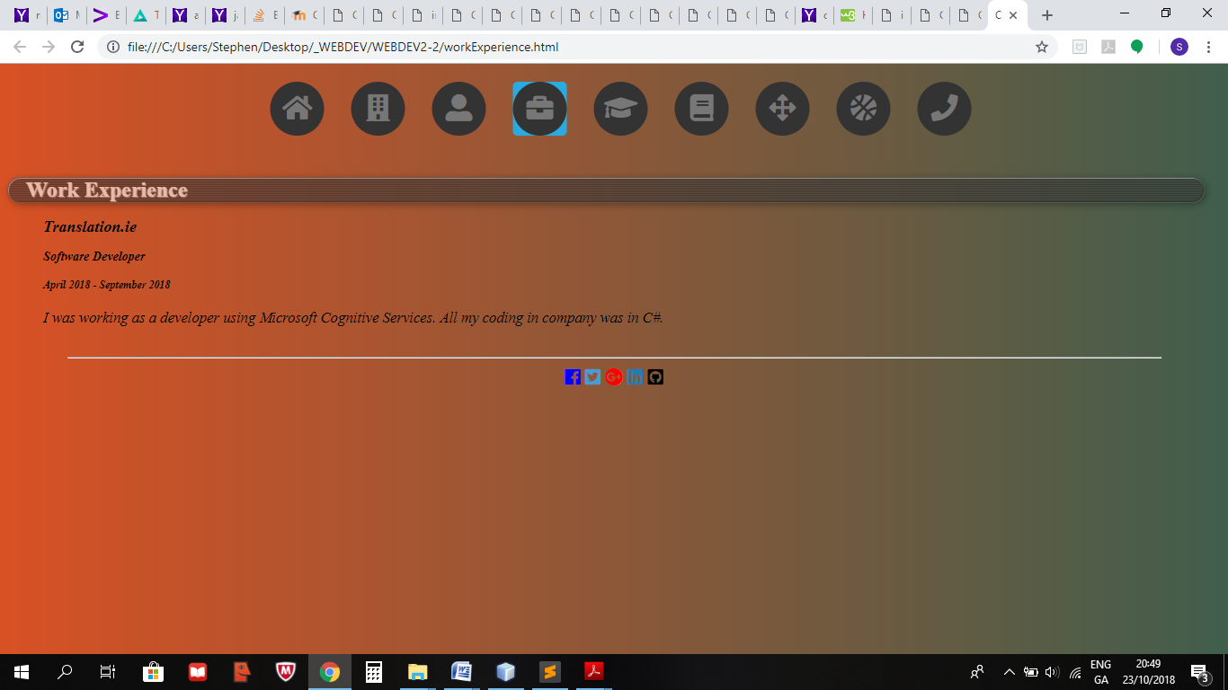

**Education.html**

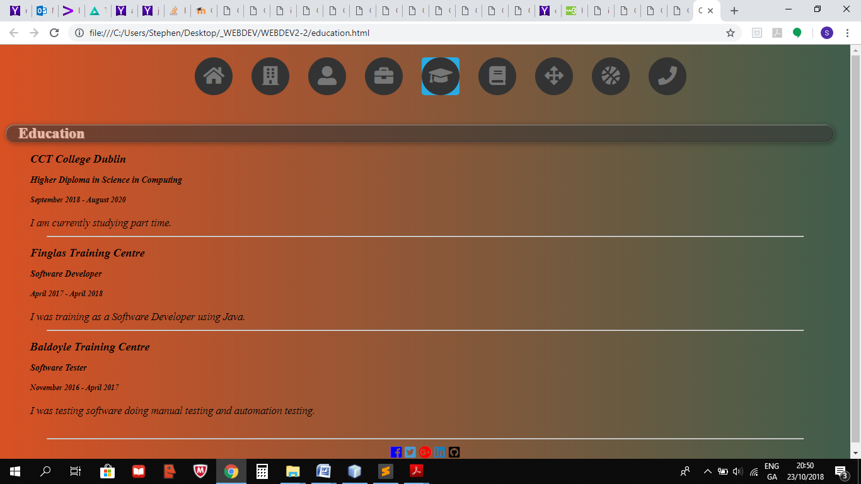

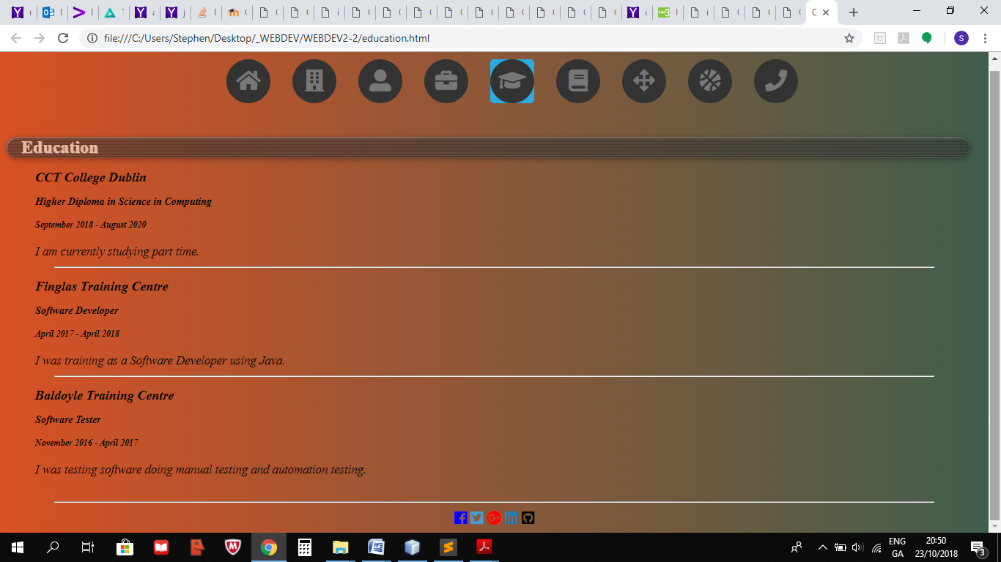

**SelfStudies.html**

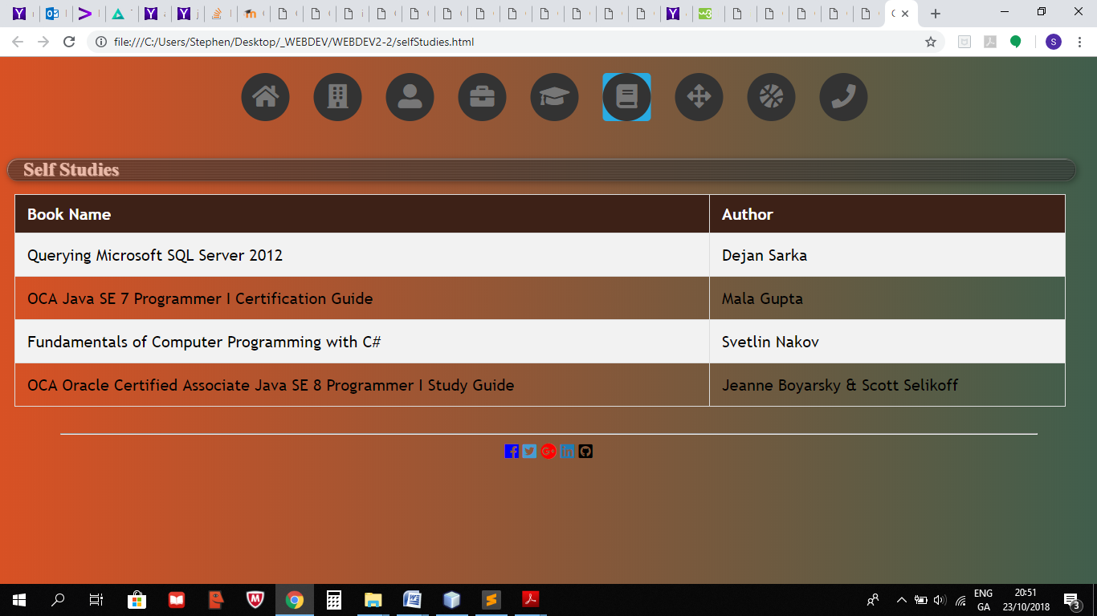

**Skills.html**

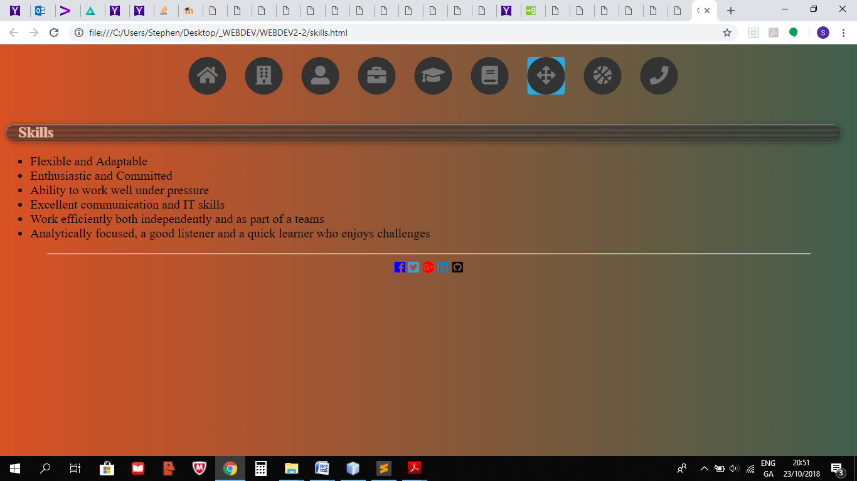

**HobbiesAndInterests.html**

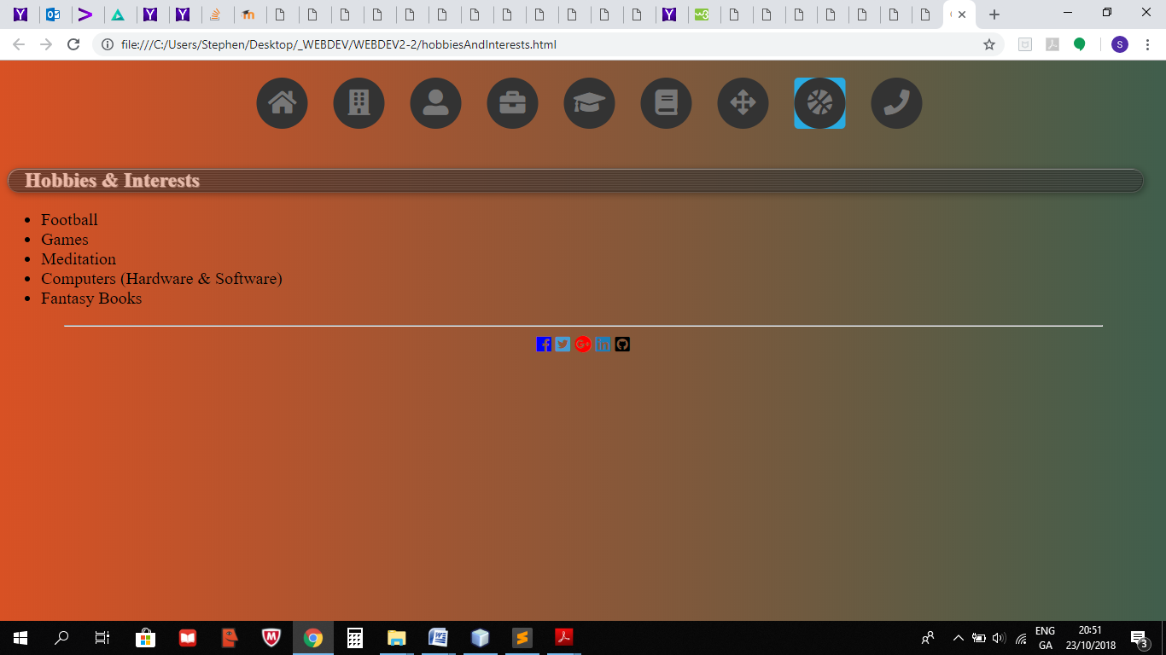

**ContactInformation.html**

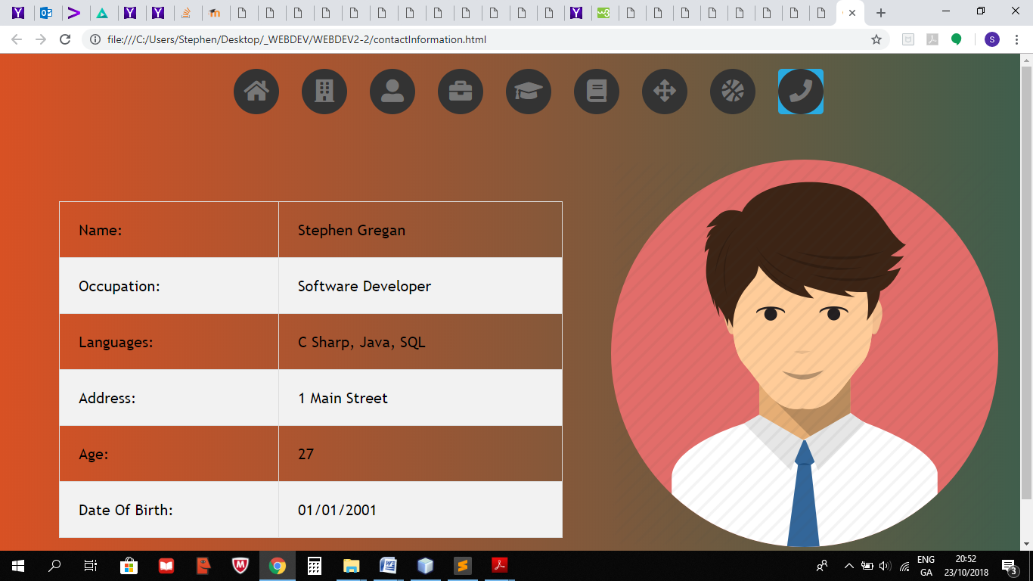

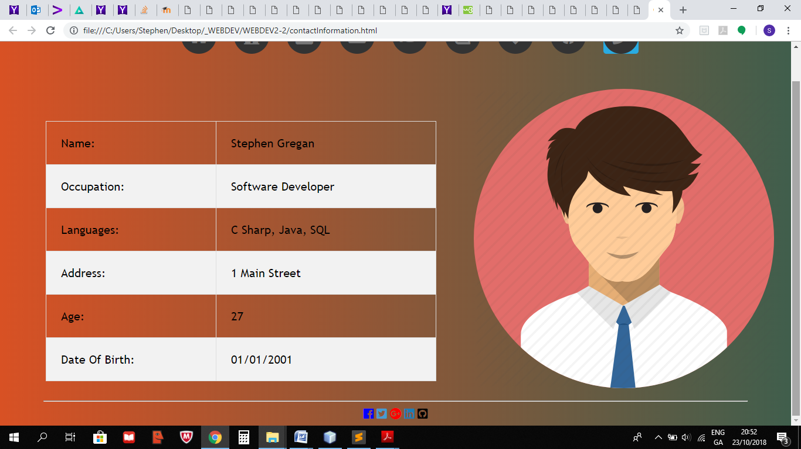

## Testing

Checked in Chrome and Internet Explorer.

## References

https://www.w3schools.com/

# Lab write up template

## Problem definition

## Design

## Website folder structure

## Code

## Screens

## Testing

## References